# **DESIGN AND DEVELOPMENT OF 10N SOLID ROCKET THRUSTER**

#### **A PROJECT REPORT**

***Submitted by***

**JEFRAN CALVIN J (19103018)**

**SANJAY V (19103019)**

**J VISHNUVARDHAN REDDY (19103049)**

###### in partial fulfillment for the award of the degree

###### of

## **BACHELOR OF TECHNOLOGY**

*in*

#### **AEROSPACE ENGINEERING**



**DEPARTMENT OF AEROSPACE ENGINEERING**

## **HINDUSTAN INSTITUTE OF TECHNOLOGY AND SCIENCE**

## **CHENNAI - 603 103**

MAY 2023

## **HINDUSTAN INSTITUTE OF TECHNOLOGY AND SCIENCE , CHENNAI - 603 103**

## **BONAFIDE CERTIFICATE**

##### Certified that this project report titled **“DESIGN AND DEVELOPMENT OF 10N SOLID ROCKET THRUSTER”** is the bonafide work of **“JEFRAN CALVIN J (19103018), SANJAY V (19103019), J VISHNUVARDHAN REDDY (19103049)”** who carried out the project work under my supervision. Certified further that to the best of my knowledge the work reported here does not form part of any other project / research work on the basis of which a degree or award was conferred on an earlier occasion on this or any other candidate.

**HEAD OF THE DEPARTMENT SUPERVISOR**

Dr.P. Vasanthakumar, Dr. Vishnu Kumar. G. C

Professor Associate Professor

Department of Aeronautical Engineering Department of Aeronautical Engineering Hindustan Institute of Technology & Science Hindustan Institute Technology & Science Padur Padur

The Project Viva-Voce Examination is held on

**INTERNAL EXAMINER EXTERNAL EXAMINER**

**ACKNOWLEDGEMENT**

We would like to place on record our sincere thanks to all those who contributed to the successful completion of our final year project work.

It’s a matter of pride and privilege for us to express our deep gratitude to the management of Hindustan Institute of Technology and Science for providing us with the necessary facilities and support.

We express our deep sense of gratitude to our respected Chairperson **Dr. (Mrs.) Elizabeth Verghese** and Pro-Chancellor **Dr. Anand Jacob Verghese** for giving us an opportunity to do the project.

We would like to thank our Director **Mr. Ashok Verghese** and Vice-Chancellor **Dr. S.N. Sridhara** for giving us moral support to complete this project.

We would like to express our grateful thanks to Dean (E&T)) **Dr. Angelina Geetha** and Registrar **Dr. Pon. Ramalingam** for support and encouragement.

We extend our sincere thanks to our Head of the Department **Dr. P. Vasanthakumar**  for inspiring and motivating us to complete this project.

We would like to thank our guide **Dr. Vishnu Kumar. G. C** for continually guiding and actively participating in our project, giving valuable suggestion to complete our project.

We would like to thank all the faculty members of the School of Aeronautical Sciences, who have directly or indirectly extended their support.

Last, but not least, we are deeply indebted to our parents who have been our greatest support while we worked day and night for the project to make it a success.

**TABLE OF ABBREVIATIONS**

|  |  |
| --- | --- |
| **SYMBOLS (or) LETTERS** | **DESCRIPTION** |
| k | Specific Heat Ratio |
| $$P_{e}$$ | Exit Pressure |
| $$P_{c}$$ | Chamber Pressure |
| f | Factor of Safety |
| $$A_{e}$$ | Exit Area of the Nozzle |
| $$A_{t}$$ | Throat Area of the Nozzle |
| $$δ$$ | Ultimate Tensile Strength |
| $$t_{ch}$$ | Chamber Thickness |
| $$\dot{m}$$ | Mass flow rate |
| $$ρ_{t}$$ | Density at Throat |
| $$V_{e}$$ | Exit velocity |
| T | Thrust |
| $$I_{sp}$$ | Specific Impulse |
| c | Core diameter |

**LIST OF FIGURES**

|  |  |  |
| --- | --- | --- |
| **FIGURE NO.** | **TITLE** | **PAGE NO.** |
| 1.2.1 | Different types of grain shapes | 2 |
| 2.2.1 | CAD Model of KNSB rocket model | 6 |
| 2.2.2 | Comparison between Experimental, Numerical studies | 6 |
| 2.2.3 | 3D view of Rocket model | 7 |
| 2.2.4 | Von-mises Stress analysis of solid rocket motor case | 8 |
| 2.2.5 | Main motor design with four propellant segments | 9 |
| 2.2.6 | Nozzle Expansion Ratio vs Inlet, Nozzle Expansion Ratio vs outlet Parabolic angles | 9 |
| 3.2.1 | Existing Nozzle Design | 12 |
| 3.3.1 | Proposed Design of Nozzle | 12 |
| 5.1.1 | Convergent Section | 19 |
| 5.1.2 | Divergent Section | 19 |
| 5.1.3 | Nozzle Design | 20 |
| 5.2.1 | Propellant Grain Design | 20 |
| 5.3.1 | Front view of Combustion Chamber | 21 |
| 5.3.2 | Top View of Combustion Chamber | 21 |
| 5.4.1 | Overall cut out section of Entire Design | 22 |
| 6.2.1 | Static Pressure Contour | 23 |
| 6.2.2 | Static Pressure variation along the length of the Nozzle | 23 |
| 6.3.1 | Mach Number Contour | 24 |
| 6.3.2 | Mach Number variation along the Length of Nozzle | 24 |
| 6.4.1 | Static Temperature Contour | 25 |
| 6.4.2 | Static Temperature variation along the length of Nozzle | 25 |
| 7.1.1 | Test stand fabrication | 27 |
| 7.1.2 | Top view of Test stand | 27 |
| 7.1.3 | Rocket Motor Holder with load cell attachment | 28 |
| 7.2.1 | Cap | 29 |
| 7.2.2 | Combustion Chamber | 29 |
| 7.2.3 | Nozzle | 29 |
| 7.2.4 | Entire Assembly of the Rocket Model | 30 |
| 7.2.5 | Entire Assembly of the Model with test stand | 30 |
| 7.2.6 | Different ways of positioning the rocket model | 31 |
| 8.1.1 | Propellant preparation | 33 |
| 8.1.2 | Propellant casting | 33 |
| 8.1.3 | Different configurations of propellant casting | 34 |
| 8.1.4 | Pallet at t = 0 secs | 35 |
| 8.1.5 | Pallet at t = 5 secs | 35 |
| 9.2.1 | At t = 0 secs(Internal Burning tube with core of 5mm) | 37 |
| 9.2.2 | At t = 30 secs(Internal Burning tube with core of 5mm) | 37 |
| 9.2.3 | At t = 70 secs(Internal Burning tube with core of 5mm) | 37 |
| 9.2.4 | At t = 120 secs(Internal Burning tube with core of 5mm) | 38 |
| 9.3.1 | At t = 10 secs(Internal Burning tube with core of 21mm) | 38 |
| 9.3.2 | At t = 25 secs(Internal Burning tube with core of 21mm) | 39 |
| 9.3.3 | At t = 45 secs(Internal Burning tube with core of 21mm) | 39 |
| 9.4.1 | At t = 0 secs(End burning grain configuration) | 40 |
| 9.4.2 | At t = 40 secs(End burning grain configuration) | 40 |
| 9.4.3 | At t = 90 secs(End burning grain configuration) | 40 |
| 9.4.4 | At t = 130 secs(End burning grain configuration) | 41 |
| 9.5.1 | Analysis of Residue after the combustion | 42 |
| 10.2.1 | Thrust vs Time(Internal Burning tube of core 5mm) | 43 |
| 10.3.1 | Thrust vs Time(Internal Burning tube of core 21mm) | 44 |
| 10.4.1 | Thrust vs Time(End Burning Grain) | 45 |
| 10.5.1 | Comparison of Thrust vs weight with different studies | 46 |
| 11.3.1 | Scaled rocket model(future enhancement) | 48 |
| 11.3.2 | Flight plan for scaled rocket model(future enhancements) | 48 |

**LIST OF TABLES**

|  |  |  |
| --- | --- | --- |
| **TABLE NO.** | **TITLE** | **PAGE NO.** |
| 4.1 | Nozzle Parameters | 15 |
| 4.2 | Propellant Geometry | 16 |
| 7.1 | Properties of Stainless Steel 310(SS 310) | 28 |
| 8.1 | Propellant Properties | 32 |
| 9.1 | Internal Burning tube grain with core diameter of 5mm | 36 |
| 9.2 | Internal Burning tube grain with core diameter of 21mm | 38 |
| 9.3 | End Burning Grain configuration | 39 |
| 10.1 | Results for internal burning tube of core 5 mm | 43 |
| 10.2 | Results for internal burning tube of core 21 mm | 44 |
| 10.3 | Results for end burning grain configuration | 45 |

**ABSTRACT**

The present study proposes to design, fabricate and test the solid rocket thruster using the KNSU propellant consisting of Potassium Nitrate as the Oxidizer and Sugar as the fuel. Basic grain geometry like an internal burning tube is chosen to simplify the analysis. Present study consists of the designing the Combustion chamber and Nozzle parmaeters for 10N thrust. Hereby, the thickness and geometry of the chamber is based on the maximum pressure and quantity of the propellant respectively. Nozzle design is based on the pressure ratio of 30 between the chamber and exit. The design of the nozzle is further verified using the Ansys Fluent software. With the above geometry of propellant and nozzle design, the thrust calculated will be around 10N. Fabrication is done using the stainless steel as the material due its properties of availability and higher melting points. The results obtained in the experimental phase are compared with theoretical calculations.

## **TABLE OF CONTENTS**

|  |  |  |
| --- | --- | --- |
| **CHAPTER NO.** | **TITLE** | **PAGE NO.** |
|  | List of Abbreviations | iii |
| List of Figures | iv |
| List of Tables | viii |
| Abstract | ix |
| 1 | **INTRODUCTION** |  |
|  | 1.1 Introduction | 1 |
|  | 1.2 Introduction to solid propellants | 1 |
|  | 1.3 Motivation for the work | 2 |
|  | 1.4 Objective of the work | 3 |
|  | 1.5 Organization of the project work | 3 |
|  | 1.6 Summary | 4 |
| 2 | **LITERATURE SURVEY** |  |
|  | 2.1 Introduction | 5 |
|  | 2.2 Earlier studies | 5 |
|  | 2.3 Summary | 10 |
| 3 | **METHODOLOGY** |  |
|  | 3.1 Introduction | 11 |
|  | 3.2 Disadvantages in the existing system | 11 |
|  | 3.3 Proposed System | 12 |
|  | 3.4 Summary | 13 |
| **4** | **CALCULATIONS FOR THE DESIGN** |  |
|  | 4.1 Nozzle Geometry | 14 |
|  | 4.2 Propellant Geometry | 16 |
|  | 4.3 Combustion Chamber Geometry | 16 |
|  | 4.4 Performance Calculations | 17 |
|  | 4.5 Conclusion | 18 |
| **5** | **DESIGNING OF THE ROCKET MODEL** |  |
|  | 5.1 Nozzle Design | 19 |
|  | 5.2 Propellant Grain Design | 20 |
|  | 5.3 Combustion Chamber Design | 21 |
|  | 5.4 Cut out section of Entire Design | 22 |
|  | 5.5 Conclusion | 22 |
| **6** | **NOZZLE VERIFICATION** |  |
|  | 6.1 Introduction | 23 |
|  | 6.2 Static Pressure Contour | 23 |
|  | 6.3 Mach Number Contour | 24 |
|  | 6.4 Static Temperature Contour | 25 |
|  | 6.5 Conclusion | 26 |
| **7** | **FABRICATION** |  |
|  | 7.1 Construction of Test stand | 27 |
|  | 7.2 Rocket Model Fabrication | 28 |
|  | 7.3 Entire Assembly of the model with the test stand | 30 |
|  | 7.4 Conclusion | 31 |
| **8** | **PROPELLANT PREPARATION** |  |
|  | 8.1 Introduction | 32 |
|  | 8.2 Propellant Testing | 35 |
|  | 8.3 Conclusion | 35 |
| **9** | **STATIC FIRE TESTING** |  |
|  | 9.1 Introduction | 36 |
|  | 9.2 Internal Burning tube grain with core diameter of 5 mm | 36 |
|  | 9.3 Internal Burning tube grain with core diameter of 21 mm | 38 |
|  | 9.4 End Burning grain configuration | 39 |
|  | 9.5 After Burn | 41 |
|  | 9.6 Conclusion | 42 |
| **10** | **RESULTS AND DISCUSSION** |  |
|  | 10.1 Introduction | 43 |
|  | 10.2 Internal Burning tube grain with core diameter of 5 mm | 43 |
|  | 10.3 Internal Burning tube grain with core diameter of 21 mm | 44 |
|  | 10.4 End Burning grain configuration | 45 |
|  | 10.5 Validation | 46 |
|  | 10.6 Summary | 46 |
| **11** | **CONCLUSION AND FUTURE ENHANCEMENT** |  |
|  | 11.1 Introduction | 47 |
|  | 11.2 Limitations of the present study | 47 |
|  | 11.3 Future Enhancements | 47 |
|  | 11.4 Conclusion | 48 |
|  | **REFERENCES** | 49 |

**CHAPTER 1**

**INTRODUCTION**

**1.1 INTRODUCTION**

The act of altering a body's motion is referred to as propulsion in a wide sense. When a body's motion is opposed by a medium, propulsion mechanisms generate a force that propels originally still bodies, alters their velocity, or overcomes opposing forces that would otherwise slow them down. In jet propulsion, an object moves by receiving a reaction force from the momentum of ejected material. A kind of jet propulsion known as rocket propulsion creates thrust by ejecting stored material, known as the propellant. Rocket Propulsion systems can be classified according to the type of energy source, the basic function, the propellant type,size etc..,so according to the propellant type they are classified as Solid, Liquid and Hybrid propellant rockets. The present study is regarding solid propellant rockets.

Chemical rockets called solid-fuel rockets burn their propellant in a solid form. Solid-propellant motors can be built, maintained, and run for very little money. They deliver a lot of force and are really dependable. The drawback is that once lit, they cannot be extinguished and their thrust cannot be controlled. In addition, they have less precise impulse than conventional liquid propellant engines. They are mostly employed as first-stage boosters to increase the rocket's performance upon launch. But for smaller rockets and to the shorter distances to reduce the complexity solid propellants are used. So our research tends to increase the specific impulse by the design modifications.

**1.2 INTRODUCTION TO KNSU PROPELLANT**

The KNSU propellant consisting of Potassium Nitrate as the Oxidizer and Sugar as the fuel. Based on the applications, It can be casted to different grain shapes like End burner, Internal burning tube, Siots and tube …. As per the below figure. For this study internal burning tube shape is chosen such that it is progressive and less complex in design.

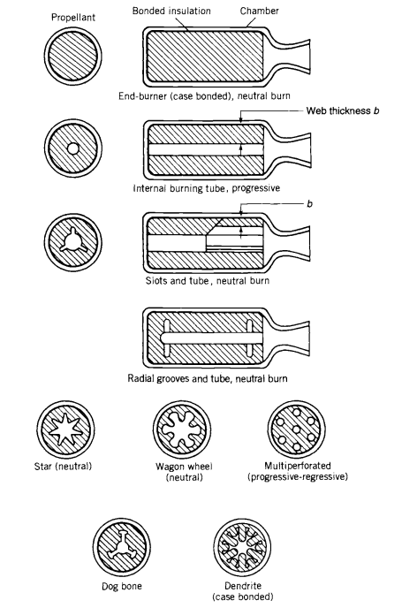

***Figure 1.2.1*** *Different types of grain shapes*

**1.3 MOTIVATION FOR THE WORK**

Sounding rockets are mostly propelled using the solid propellants by which the satellites can be launched to lower earth orbits. So in order to make a bigger one, smaller prototypes are used to estimate the performance of the original one in such a manner we decided to construct a smaller solid propellant rocket such that it paves way for making the bigger scale rockets in future.

**1.4 OBJECTIVE OF WORK**

The objectives of the project are :

* Studying the composition of Potassium Nitrate and Sucrose in the KNSU propellant.
* Improving the Nozzle characteristics from the previous studies.
* Static Test firing of the rocket model with the test stand.
* Comparing the results obtained through experimental and theoretical analysis.

**1.5 ORGANISATION OF THE PROJECT WORK**

The thesis was organised in such a way which gives clear idea behind the

methodology followed in the project followed by the literature survey, work done

and the discussion on the results obtained and concludes with the future

enhancement of the project. The following is the summary of the chapters

included in the thesis:

**Chapter 1**: Provides an introduction to the project and also the objective and motivation for work.

**Chapter 2**: Summarizes the important conclusions from the literature survey and

discusses the various observations based on previous research carried out by

various researchers in this field.

**Chapter 3**: Summarizes the methodologies and the procedures followed to obtain

the various design and performance parameters required for the rocket model.

**Chapter 4, 5, 6 and 7**: Elaborates the calculations, Design, Nozzle flow analysis and methods of fabrication for the rocket model.

**Chapter 8**: Discusses the steps followed in propellant preparation.

**Chapter 9:** Experimental part of this work is briefly explained in this chapter.

**Chapter 10:** Comparative study of Theoretical and Experimental results are discussed in this chapter.

**Chapter 11:** Discusses the possible future enhancements and concludes the work.

**Chapter 12:** Lists all the literature referred for the project.

**1.6 Summary**

The motivation to carry out this project work, objective, broad scope of the study and the thesis organization are presented in this chapter.

**CHAPTER 2**

**LITERATURE SURVEY**

**2.1 INTRODUCTION**

Solid propellants have been used in a wide range of applications, including as the main propulsion system for space launch vehicles, as a maneuvering system for satellites and spacecraft, and as the propellant for military missiles and rockets. They have also been used in a variety of scientific research applications, such as sounding rockets for atmospheric research and high-altitude balloon flights. There are different types of solid propellants varying with the mission type and many researchers performed their experiments and research over the solid propellants. Some of them are discussed below.

**2.2 EARLIER STUDIES**

Malek(2019) [1] worked on KNSB propellant and designing of a rocket model with mild steel material. The design of the rocket model is completely based on the SRM 2014.xls by Richard A Nakka in which the Nozzle design is conical at both the convergent and divergent parts of the model. The author estimated the thrust to be generated around 100 N, but during the experimental analysis it is around 75 N. The propellant grain is in the shape of BATES. The details of the model are given in the figure below.

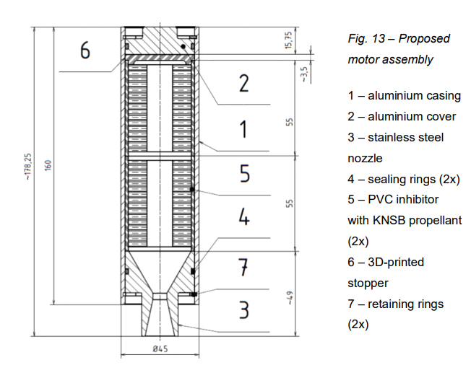

***Figure 2.2.1*** *CAD Model of KNSB rocket model*

Dequick et al(2020)[2] conducted an experiment on the hybrid rocket engines with paraffin based propellant, $N_{2}O$ based oxidiser and performed CFD simulation. The results of the experimental part and simulation are compared. Arrangement of the propellant and oxidiser with maintaining the pressure are discussed in brief.

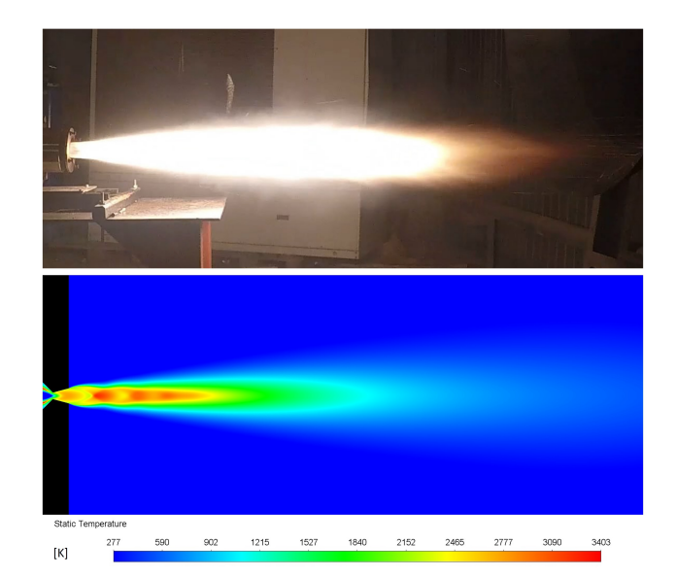

***Figure 2.2.2*** *Comparison between Experimental, Numerical studies*

Durajoye et al(2018)[3] designed a sugar based solid propellant rocket using KNSU propellant of 5 kgs which is capable of generating Mach number of 5. In this the authors used the Propep simulation software for the input data regarding the KNSU propellants. Finally found that the model is capable of generating thrust around 2000 N and the material used for construction is mild steel. It also found that the thickness of the chamber is much related to the hoop stress, the maximum stress of the cylindrical chamber subjected to pressure.

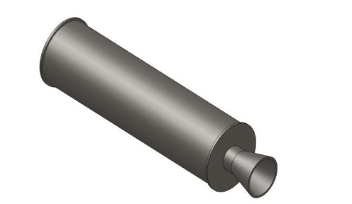

**Figure 2.2.3** *3D view of Rocket model*

Nelson et al(2020)[4] analysed the cylindrical dome structures and hemispherical dome structures which are most predominantly used shapes for combustion chambers of solid rockets. Many calculations and comparison studies performed for both Hoop stress and longitudinal stress. Along with which the structural analysis is performed using ansys in which the maximum pressure is around 6 MPa and results are compared.

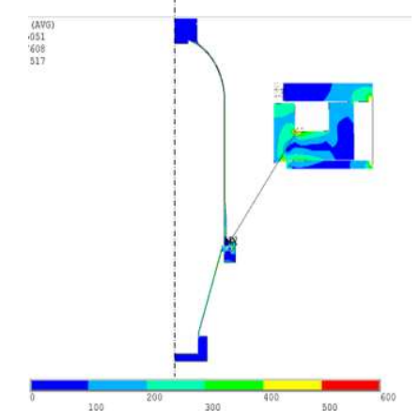

***Figure 2.2.4*** *Von mises Stress analysis of solid rocket motor case*

Suksila(2018)[5] described the various propellants and its casting procedure. The propellants breifed are Black powder, white powder and rocket candy propellants which are varied based on the composition of the chemicals. The most common compound is potassium nitrate. The author provides the knowledge regarding the casting procedure of rocket candy and also static test fired and obtained the results for different dimensions of propellant. In this the basics of rocket propulsion are also explained in detail.

Nakka(2007)[6] performed many experiments using different propellants and all results are briefed in this site. So, this information is very helpful in designing the test stand and casting of KNSU propellants.

Sidhant Singh(2013)[7] discussed the different types of materials that can be used for construction of motor casing. Analysis for the prototype type is done using the software and a thrust curve is obtained for the model. For the prototype, Nozzle area ratio of 10:1 is chosen and after the analysis area ratio of the main motor is modified to 14:1 with 4 segments of propellant. With the modification, there was a slight difference observed in the operation.

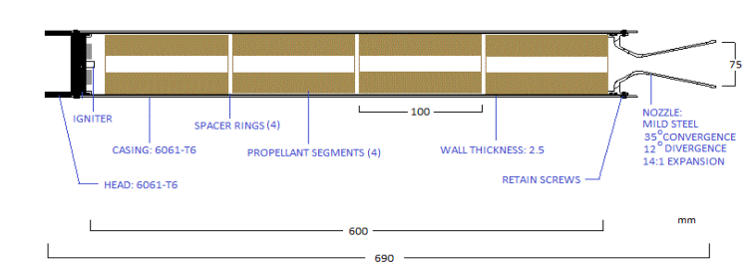

***Figure 2.2.5*** *Main motor design with four propellant segments*

Sutton et al(2001)[8] in his book rocket propulsion elements covers both liquid and solid propellant rocket engines, with a detailed analysis of the design and operation of liquid propellant engines, including turbopumps, injectors, and combustion chambers. The book also covers the basics of rocket vehicle design, including staging, guidance, and control systems.and the science behind the rocket. Most of the references for the model construction were taken from this book.

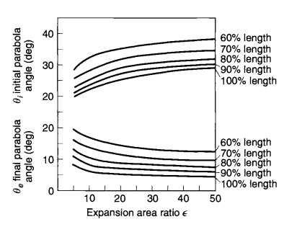

***Figure 2.2.6*** *Nozzle Expansion Ratio vs Inlet and outlet Parabolic angles*

The above figure helps in giving angles to the bell bottom nozzle i.e. the divergent section with 80% length.

Nakka(2018)[9] proposed an excel sheet for solid propellants especially for sugar based propellant which contain many parameters like density, specific heat ratio, Chamber temperature and also contains predefined formulas for the rocket construction.

**2.3 SUMMARY**

In this chapter, a brief summary of work carried out in published literature on different solid propellants with varying design conditions has been studied.

**CHAPTER 3**

**METHODOLOGY**

**3.2 DISADVANTAGES IN THE EXISTING SYSTEM**

The existing system contains conical shaped convergent and divergent sections which decreases the efficiency of the rocket model which is proven with the theoretical and experimental results. Also the propellant at the existing system is KNSB which has less Chamber temperature compared to KNSU propellant.

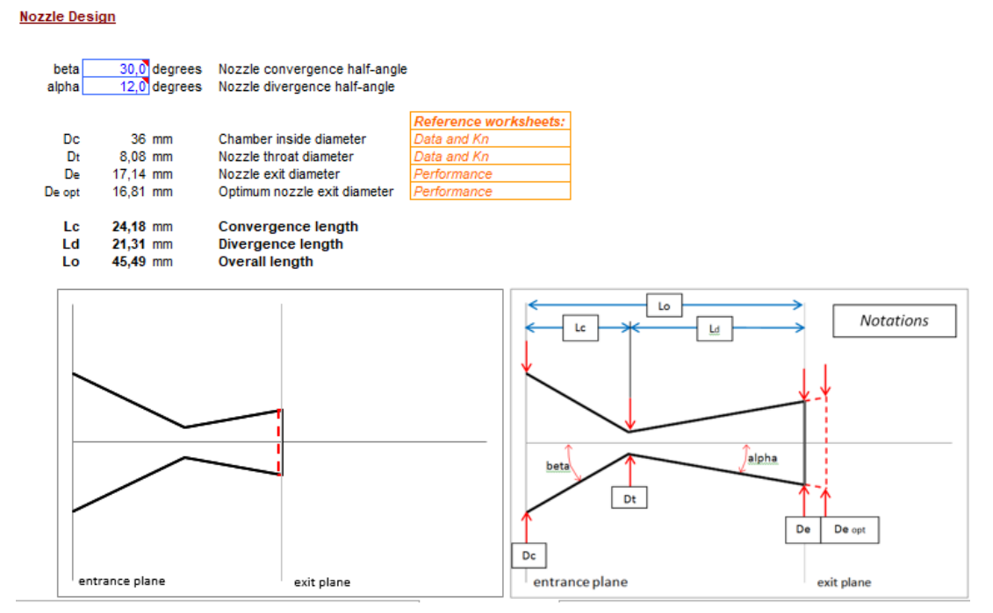

***Figure 3.2.1*** *Existing Nozzle Design*

**3.3 PROPOSED SYSTEM**

The proposed system has a nozzle with conical convergent section and bell bottom divergent section which makes the model more efficient than the existing one and also the length of model is shorter than the existing one. In order to increase the specific impulse higher chamber temperature propellants like KNSU is used.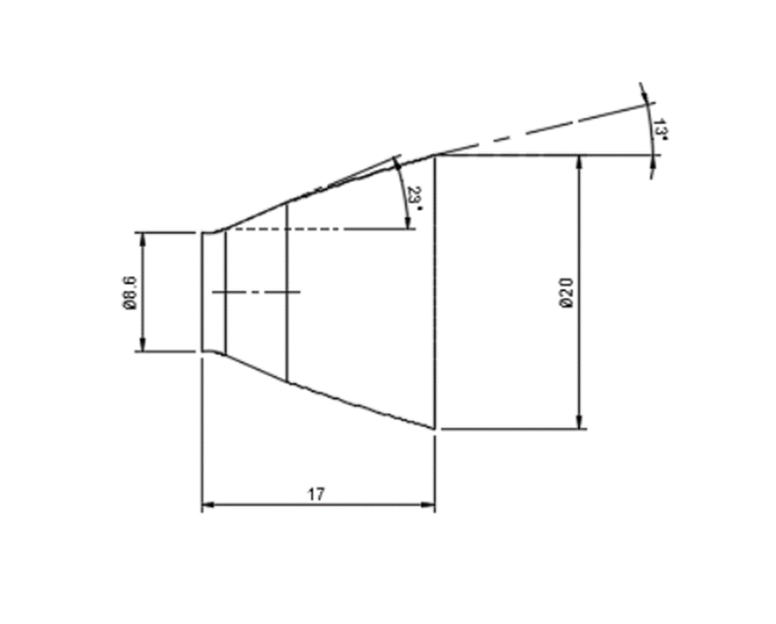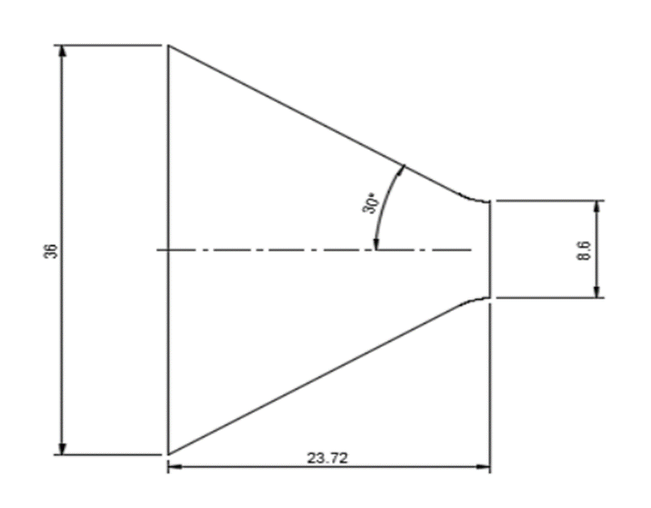

***Figure 3.3.1***  *Proposed Design of Nozzle*

**3.3 SUMMARY**

In this chapter, the methodology of the work carried out is presented. The choice of an axisymmetric problem is also justified.

**CHAPTER 4**

**CALCULATIONS**

**4.1 Nozzle Geometry:**

**Nozzle Expansion Ratio:**

Nozzle Expansion ratio,

$$\frac{A_{t}}{A_{e}} ={ \left(\frac{k+1}{2}\right)}^{k-1}{\left(\frac{P_{e}}{P_{c}}\right)}^{\frac{1}{k}}\sqrt{\frac{k+1}{k-1}\left(1-{\left(\frac{P_{e}}{P_{c}}\right)}^{\frac{k-1}{k}}\right)}$$

Where,

k = Specific Heat Ratio = 1.133

$P_{e}$**=** Exit Pressure(MPa) = 0.1 MPa

$P_{c}$**=** Chamber Pressure(MPa) = 3 MPa

$\frac{A_{e}}{A_{t}}$ = Nozzle Area expansion ratio

The area expansion ratio will be 5.39.

Let the exit diameter of the Nozzle be 20 mm.

Then from the expansion ratio, the throat diameter will be 8.6 mm.

The inlet diameter of the nozzle will be 36 mm.

**Convergent section:**

The convergent section is said to have a conical shape with half angle of ${30}^{∘}$.

Length of the convergent section will be

$$L = \frac{D_{1}- D_{2}}{2*Tan({30}^{∘})}$$

Where,

$D_{1}$ = Diameter of the inlet(mm) = 36 mm

$D_{2}$ = Diameter of the throat(mm) = 8.6 mm

From this length of the convergent section will be 23.72 mm.

**Divergent Section:**

The Divergent section of the nozzle is designed in the shape of Bell Bottom.

For the area ratio of 5.39, the inlet and outlet angles of the parabola will be ${23}^{∘}$ and ${13}^{∘}$ respectively.

Length of the Divergent section will be

$$L = \frac{D_{3}- D_{2}}{2*Tan({15}^{∘})}$$

Where,

$D_{3}$ = Diameter of the outlet(mm) = 20 mm

$D_{2}$ = Diameter of the throat(mm) = 8.6 mm

The nozzle is said to have 80% contour so length of the divergent section will be 17.01 mm

**Nozzle Design Parameters:**

**Table 4.1** Nozzle Parameters

|  |  |
| --- | --- |
| Nozzle Expansion Ratio | 5.39 |
| Inlet Diameter | 36 mm |
| Throat Diameter | 8.6 mm |
| Exit Diameter | 20 mm |
| **Convergent Section:**  Nozzle Half Angle | Conical shape  30° |
| **Divergent Section:**  Initial Parabolic Angle  Final Parabolic Angle | Bell Bottom Shape  23°  13° |
| **Nozzle overall Length:**  Convergent Section  Divergent Section | 40.73 mm  23.72 mm  17.01 mm |

**4.2 Propellant Geometry:**

**Table 4.2** Propellant Geometry

|  |  |
| --- | --- |
| Inlet Diameter | 15 mm |
| Outer Diameter | 36 mm |
| Height | 115 mm |

**4.3 Combustion Chamber Geometry:**

**Combustion Chamber Wall Thickness:**

Considering the material as mild steel,

$$t_{ch} = \frac{f*P*D}{2*δ}$$

Where,

f = Factor Of Safety = 10

$P_{c}$ = Maximum Chamber Pressure(MPa) = 3 MPa

D = Outer Propellant Diameter(mm) = 36 mm

$δ$**=** Ultimate Tensile Strength of Mild Steel(MPa) = 400 MPa

The thickness of the Combustion Chamber is 1.5 $mm$

**4.4 PERFORMANCE CALCULATIONS:**

**Exit Velocity:**

$V_{e} = \sqrt{\frac{2*k*R*T_{c}}{k-1}\left(1-{\left(\frac{P_{e}}{P_{c}}\right)}^{\frac{k-1}{k}}\right)}$

Where,

k = Specific Heat Ratio = 1.133

R = Specific Gas Constant( $J/kg K)$ = 198.0466 $J/kg K$

$T_{c}$**=** Chamber Temperature(K) = 1720 K

$P_{e}$**=** Exit Pressure(MPa) = 0.1 MPa

$P_{c}$**=** Chamber Pressure(MPa) = 3 MPa

The Exit Velocity obtained will be 1381.3 $m/s$

**Mass Flow Rate:**

T = $\dot{m}$ $V_{e}$

*

Where,

$V_{e}$ = Exit Velocity( $m/s)$ = 1381.3 $m/s$

Thrust expected = 10 N

The calculated mass flow rate will be 7.239 $g/s$

**Specific Impulse:**

$I_{sp}$**= $\frac{V_{e}}{g}$**

Where,

$V_{e}$ = Exit Velocity( $m/s)$ = 1381.3 $m/s$

g = Acceleration due to gravity($m/s^{2}$) = 9.81 $m/s^{2}$

The Specific Impulse will be 140.80 secs

**4.5 CONCLUSION:**

The calculations required for designing and performance parameters are briefed in this chapter. These calculations are used in the next chapters for designing and analysis.

**CHAPTER 5**

**DESIGNING OF THE ROCKET MODEL**

The Designing part is carried out using the Fusion 360 software with the help of the previously done calculations.

**5.1 Nozzle Design:**

**Convergent Section:**



***Figure 5.1.1*** *Convergent Section*

**Divergent Section**



***Figure 5.1.2*** *Divergent Section*

**Entire Nozzle Design:**

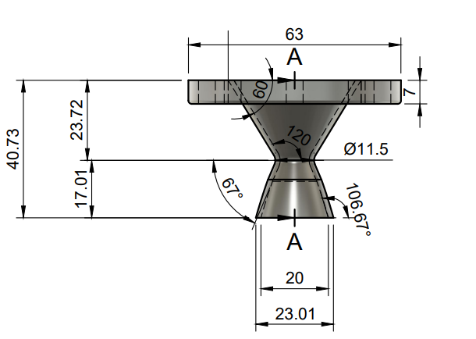

***Figure 5.1.3*** *Nozzle Design*

**5.2 Propellant Grain Design:**

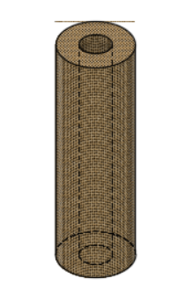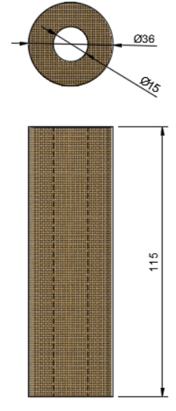

***Figure 5.2.1*** *Propellant Grain Design*

**5.3 Combustion Chamber Design:**

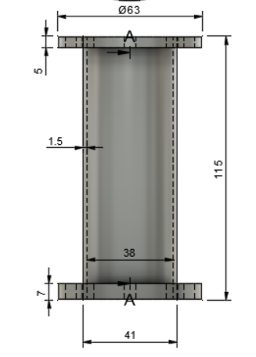

***Figure 5.3.1*** *Front view of Combustion Chamber(*

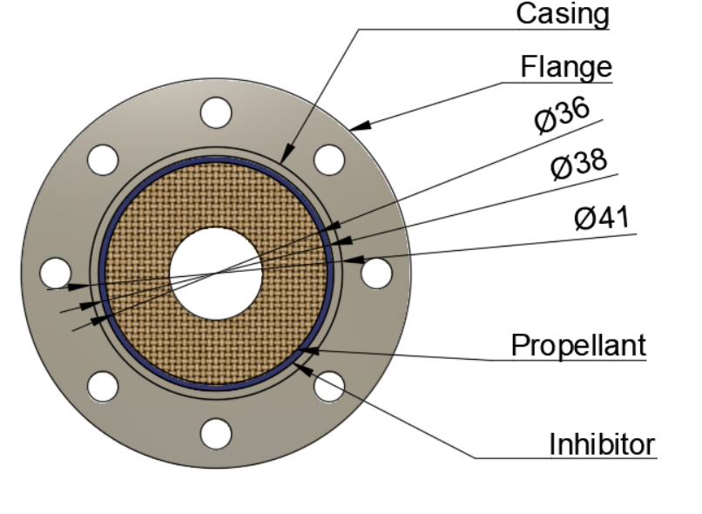

***Figure 5.3.2*** *Top View of Combustion Chamber*

**5.4 Overall cut out section of Design:**

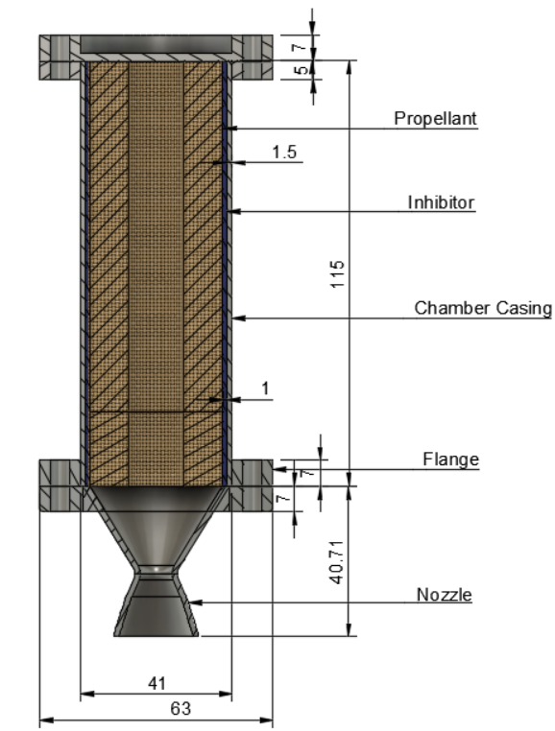

All dimension in mm

***Figure 5.4.1*** *Overall cut out section of Entire Design*

**5.5 CONCLUSION:**

The design of the parts are included with the flanges which are used to attach one another with bolts. The Design also contains the dimensions of each and every part in the units of mm.

**CHAPTER 6**

**NOZZLE VERIFICATION**

**6.1 Introduction**

Fusion 360 software is used to design the nozzle according to the angles and geometry of specific positions such the throat section, inlet, and outlet of the nozzle, and Ansys fluent software is used to analyse the design. The results obtained are as follows:

**6.2 Static Pressure Contour:**

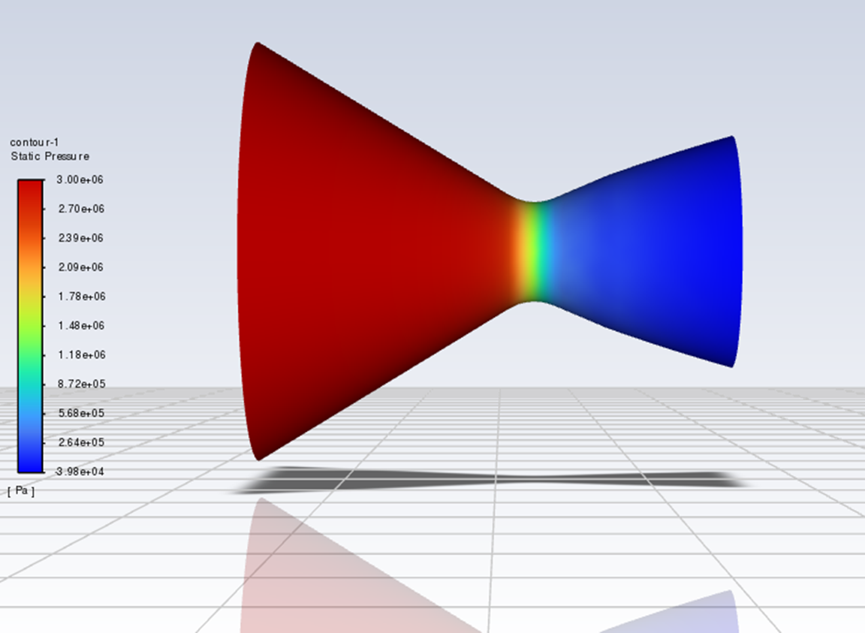

***Figure 6.2.1*** *Static Pressure Contour*

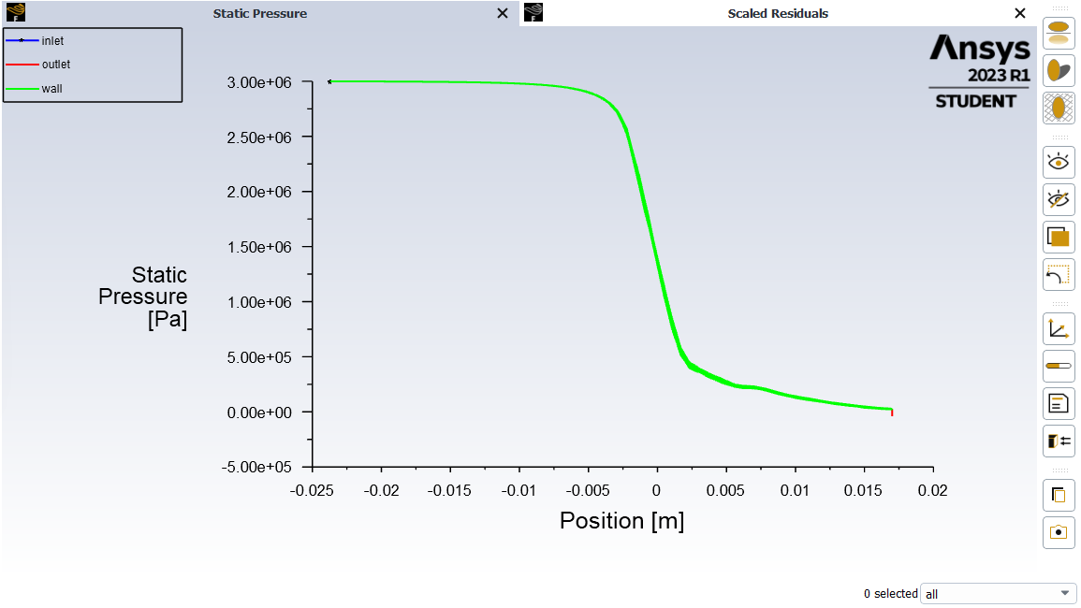

***Figure 6.2.2*** *Static Pressure variation along the length of the Nozzle*

**6.3 Mach Number Contour:**

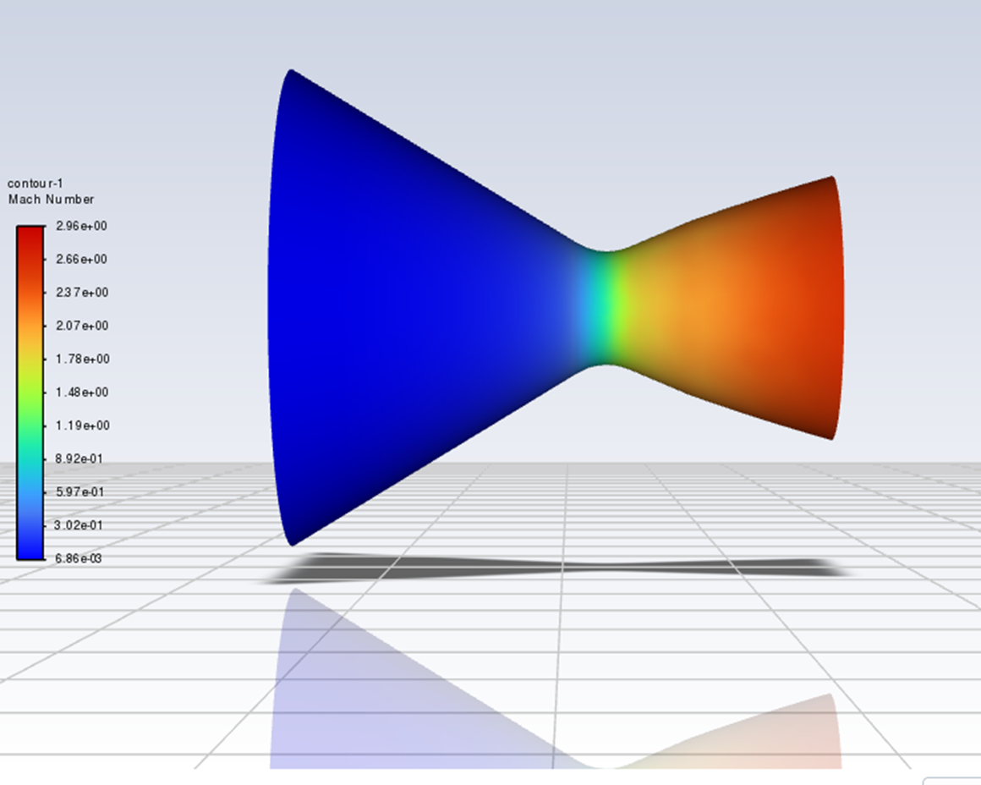

***Figure 6.3.1*** *Mach Number Contour*

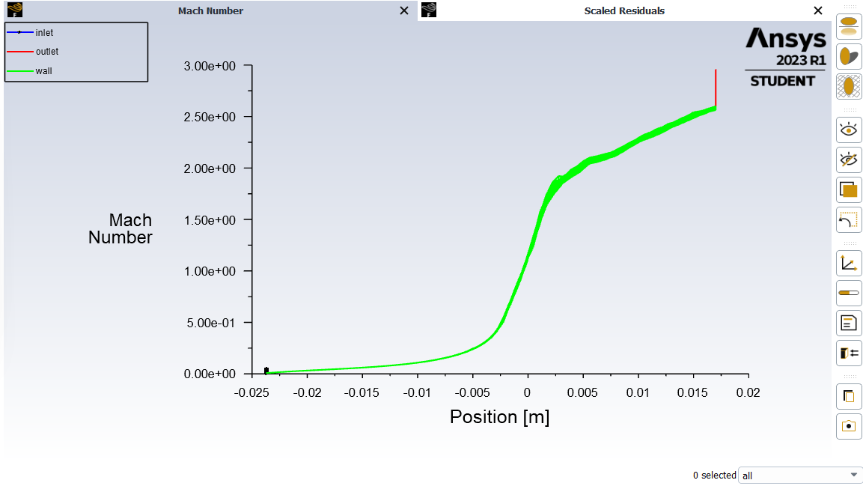

***Figure 6.3.2*** *Mach Number variation along the Length of Nozzle*

**6.4 Static Temperature Contour:**

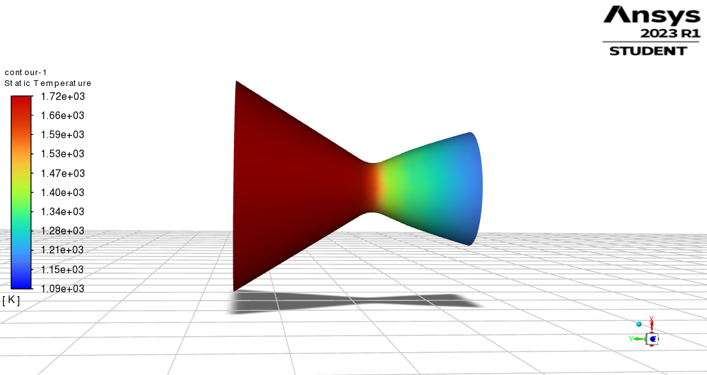

***Figure 6.4.1*** *Static Temperature Contour*

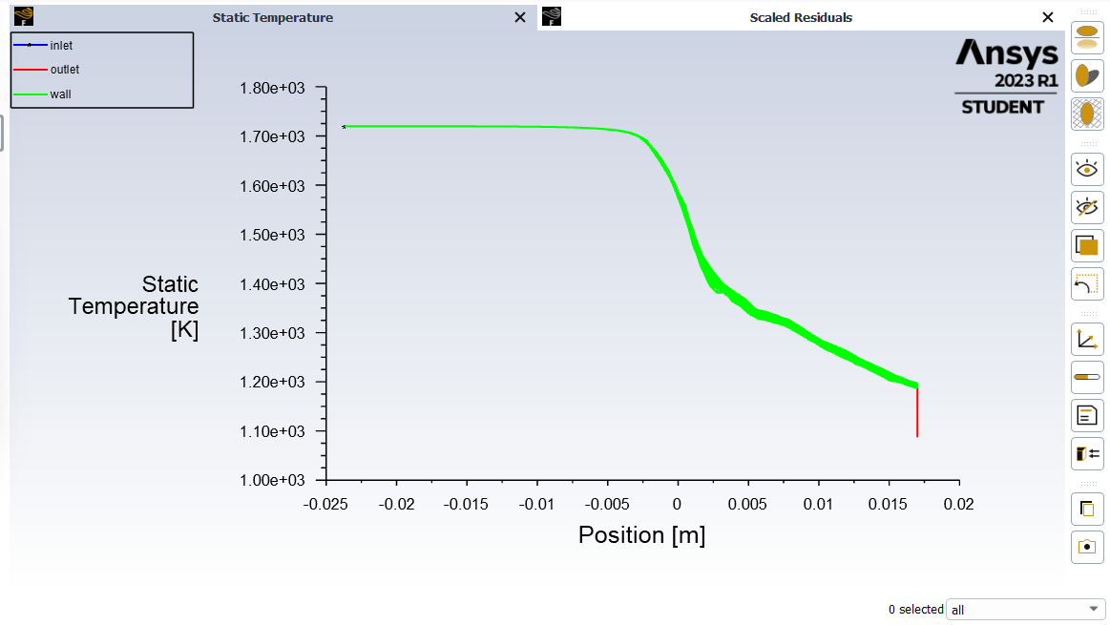

***Figure 6.4.2*** *Static Temperature variation along the length of Nozzle*

**6.5 CONCLUSION:**

The flow parameters over the nozzle are studied with the initial conditions as input, as obtained from the results above it is observed that the Nozzle output matches up with the calculations.

**CHAPTER 7**

**FABRICATION**

This chapter involves the fabrication of the test stand and the rocket model.

**7.1 TEST STAND CONSTRUCTION**

The test stand is constructed in such a way that it is capable of calculating thrust for different sizes of rockets with the help of a Load cell. The test stand is made of Iron rods and welded together.

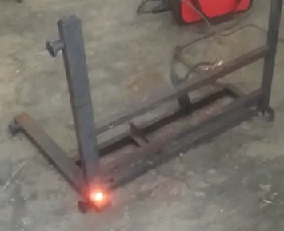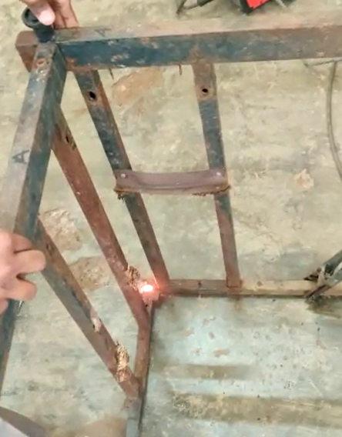

***Figure 7.1.1*** *Welding of Iron Rods*

Depending on the amount of thrust produced, the rocket can be positioned either inverted or normally.

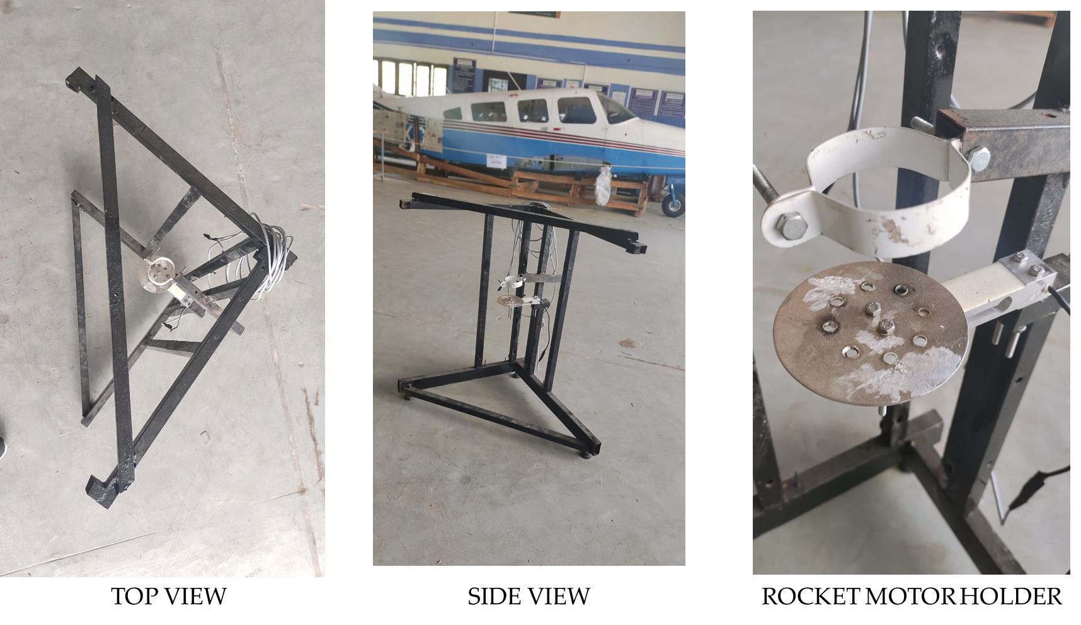

***Figure 7.1.2*** *Top view of Test stand*



***Figure 7.1.3*** *Rocket Motor Holder with load cell attachment*

The Rocket motor holder helps in holding the motor straight and minimises the vibrational errors caused during firing. The clamp at the centre can be expanded according to the requirement.

**7.2 ROCKET MODEL FABRICATION**

The Entire Rocket model is subdivided into three parts:

1. Cap
2. Combustion Chamber
3. Nozzle

According to the design presented in the earlier chapters, all three of these components are made using CNC and VMC equipment. The characteristics of the stainless steel 310 material used in fabrication are listed below.

**Table 7.1** Properties of Stainless Steel 310(SS 310)

|  |  |
| --- | --- |
| Density | 8000 $kg/m^{3}$ |
| Melting Point | 1673 - 1750 K |
| Tensile Strength | 520 MPa |
| Thickness | 2 mm |

The manufactured parts are given below:

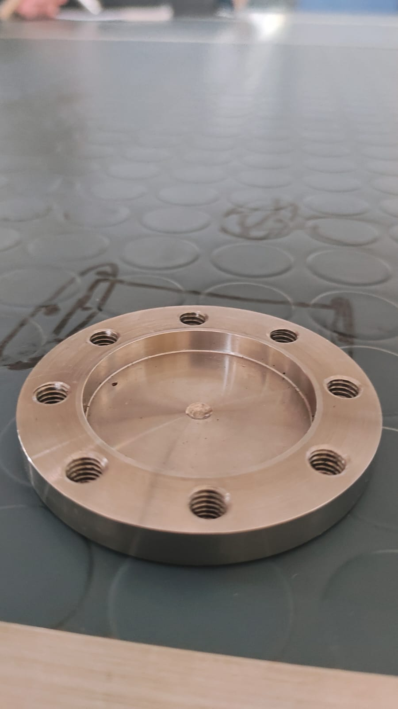

***Figure 7.2.1*** *Cap*

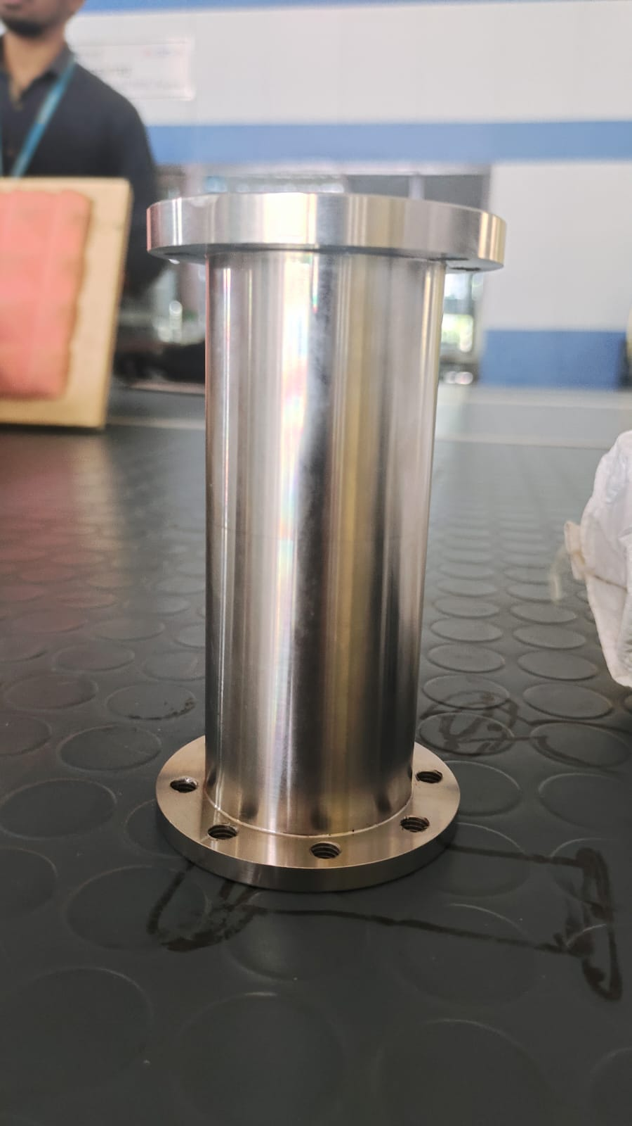

***Figure 7.2.2*** *Combustion Chamber*

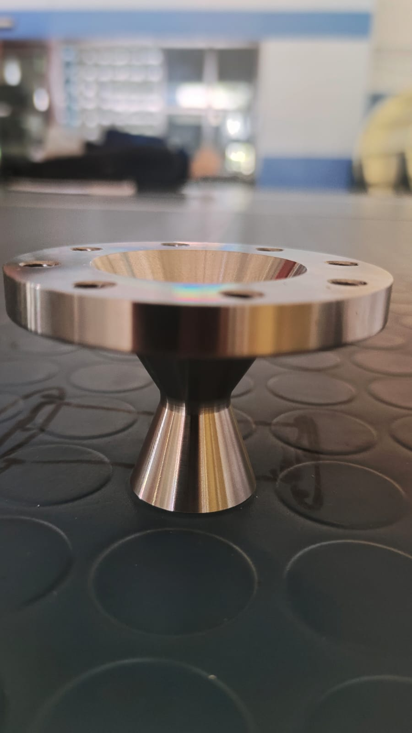

***Figure 7.2.3*** *Nozzle*

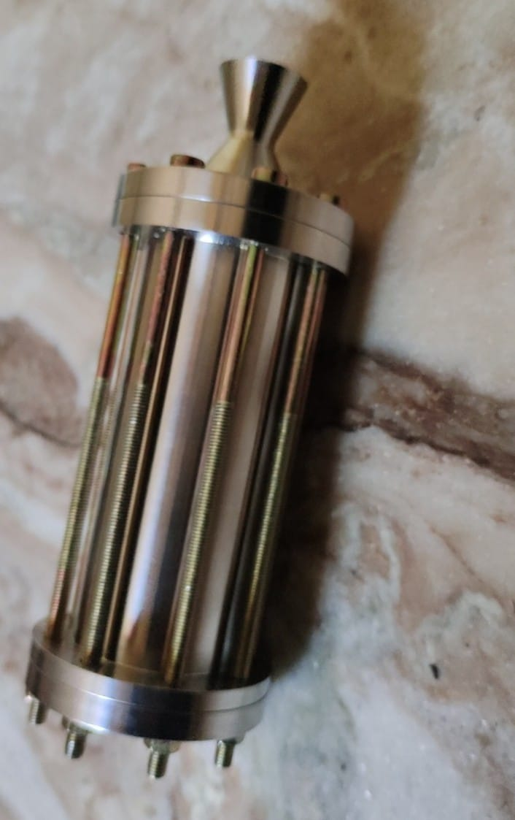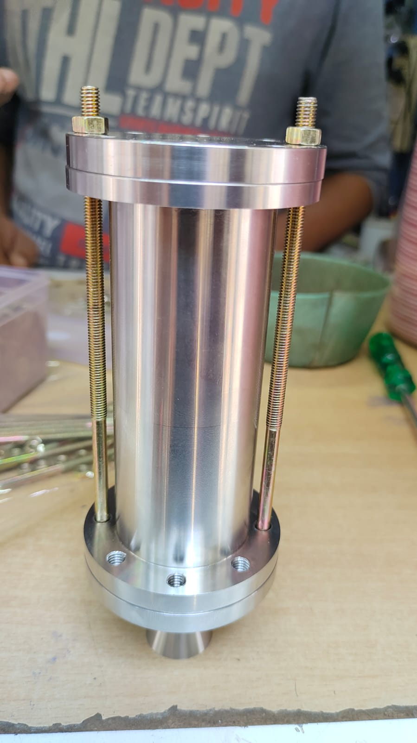

***Figure 7.2.4*** *Entire Assembly of the Rocket Model*

**7.3 ENTIRE ASSEMBLY OF THE MODEL WITH TEST STAND:**

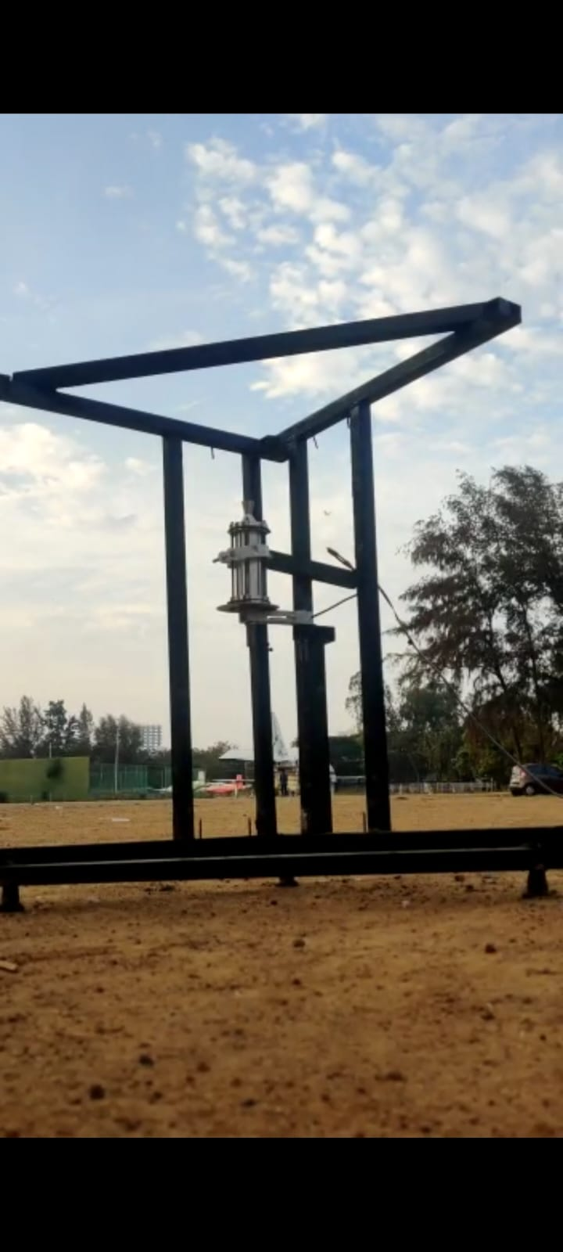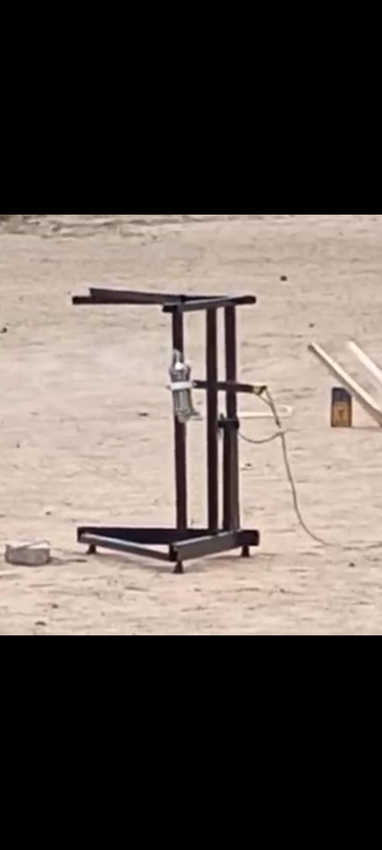

***Figure 7.2.5*** *Entire Assembly of the Model with test stand*

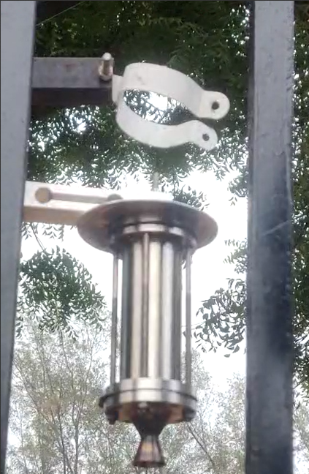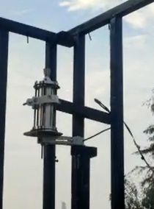

***Figure 7.2.6*** *Different ways of positioning the rocket model*

**7.4 CONCLUSION**

In this chapter, the way test stand and rocket model fabrication is well discussed and along with how the rocket model is integrated with the test stand have been explained well with the help of figures.

**CHAPTER 8**

**PROPELLANT PREPARATION**

**8.1 INTRODUCTION**

Steps involved in Propellant preparation are:

1. Choosing the correct mixture of the compounds.
2. Constant heating and stirring the compounds.
3. Casting the propellant according to the Grain configuration.
4. Curing and protecting from the external Atmosphere.

According to Richard Nakka, the first step in selecting the proper combination for a KNSU propellant is to select the conventional ratios of 65% potassium nitrate and 35% sucrose, which are anticipated to offer greater performance.[6]

**Table 8.1** Propellant Properties

|  |  |
| --- | --- |
| Propellant | KNSU |
| Density | 1889 kg/m^3 |
| Specific Heat Ratio | 1.133 |
| Composition:  Potassium Nitrate  Sucrose | 65%  35% |
| Chamber Temperature | 1720 K |
| Weight of propellant  End Burning Grain  Internal Burning tube core diameter of 5 mm  Internal Burning tube core diameter of 21mm | 210 g  170 g  96 g |
| Burning Type | Progressive Burning |

Fine powdered form of both Potassium Nitrate and Sugar is taken according to the ratios mentioned above. This mixture is heated at a constant temperature of 300 degree Celsius which involves constant stirring so that the bottom of the vessel doesn’t catch the fire. It is heated until the consistency turns to pouring form.The phases of propellant transition from powdered form to liquid form can be seen in the below figure.

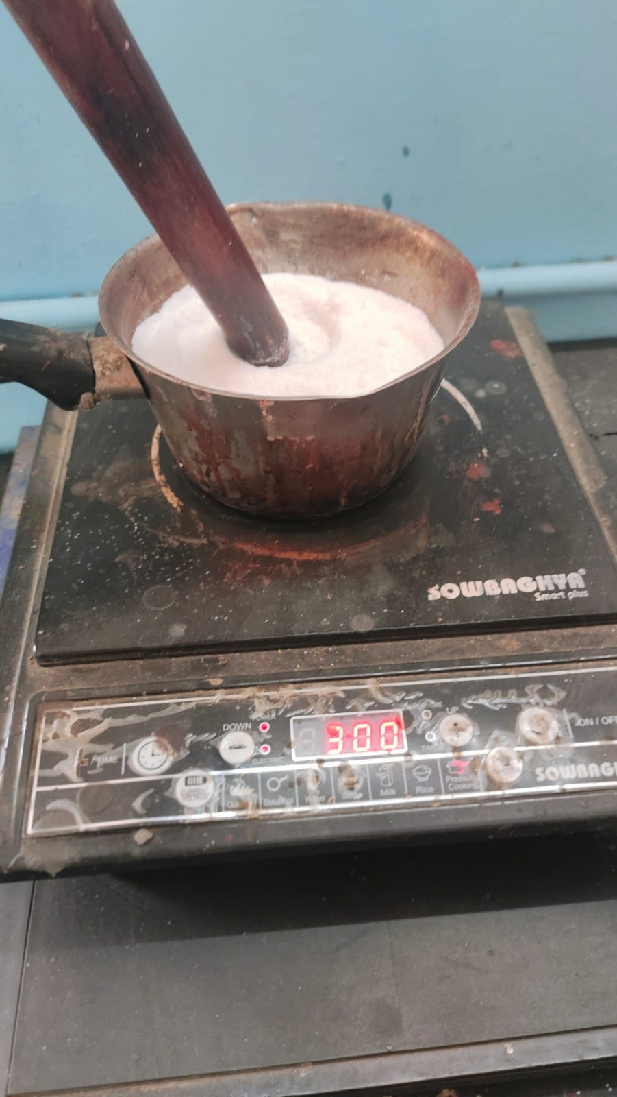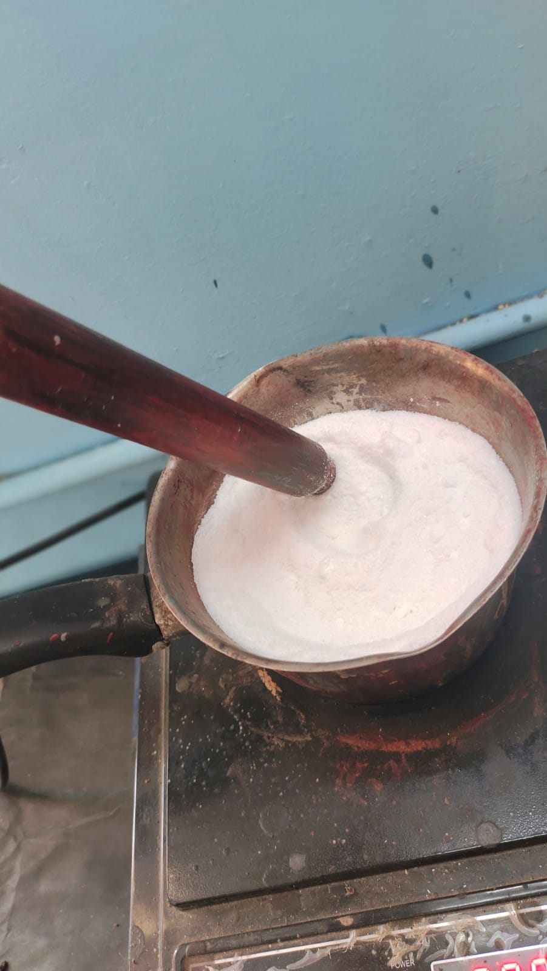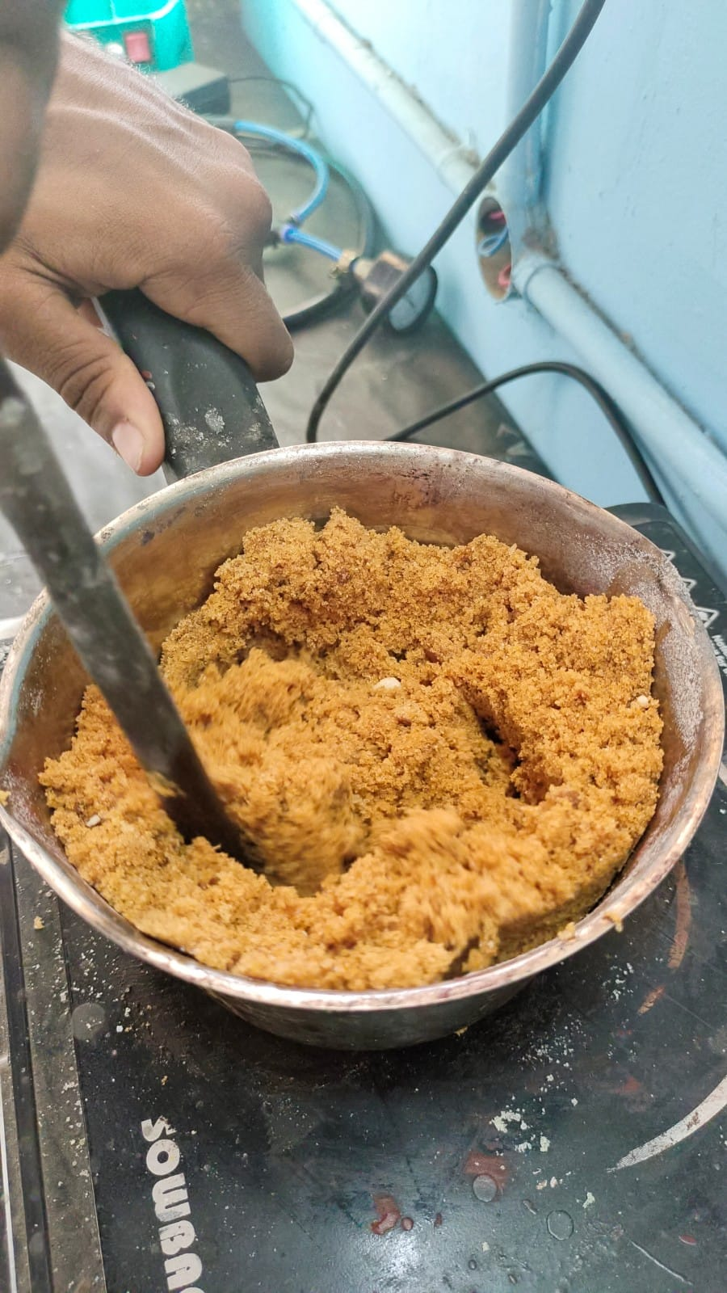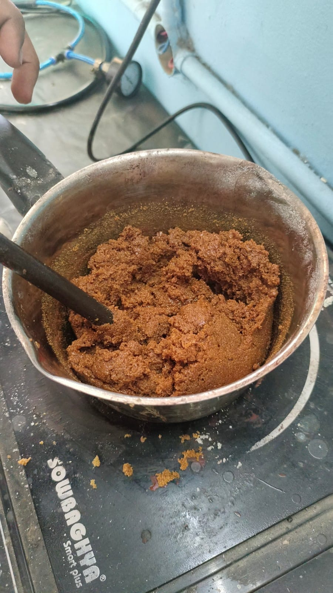

***Figure 8.1.1***  *Heating the propellant*

Casting involves proper pouring of propellant into the mould and it should be done faster so that the propellant grain doesn’t caramelise within the vessel. Some pallets of propellant is taken for testing which is shown in the below figure.

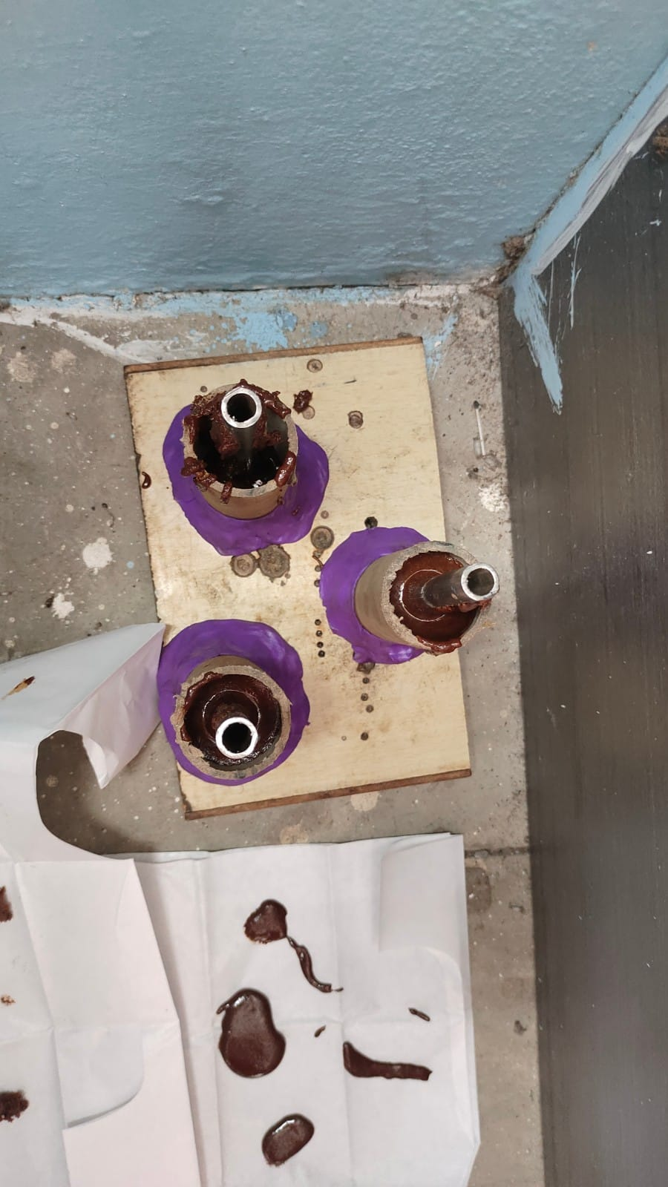

***Figure 8.1.2*** *Propellant casting*

It is done into three propellant grain configurations by varying the propellant thickness.

1. Internal Burningtube grain configuration with core diameter of 5 mm
2. Internal Burning tube grain configuration with core diameter of 21 mm
3. End Burning Grain Configuration

The process is the same for all the grains except the casting. The variation in the grain configuration can be seen through the below figure.

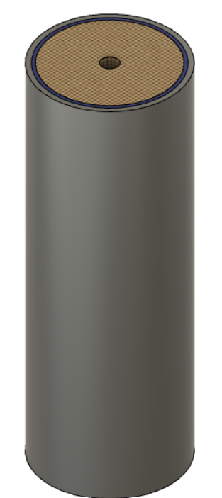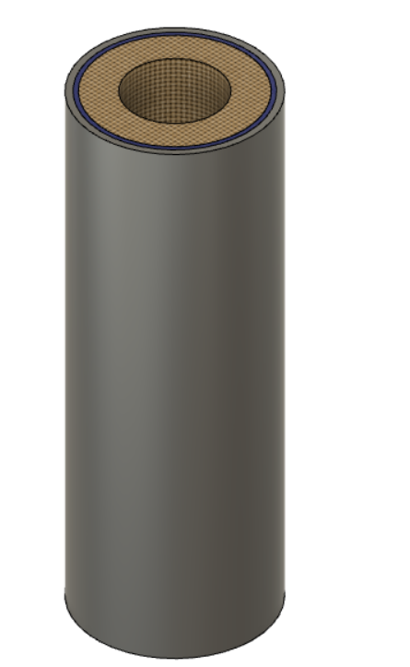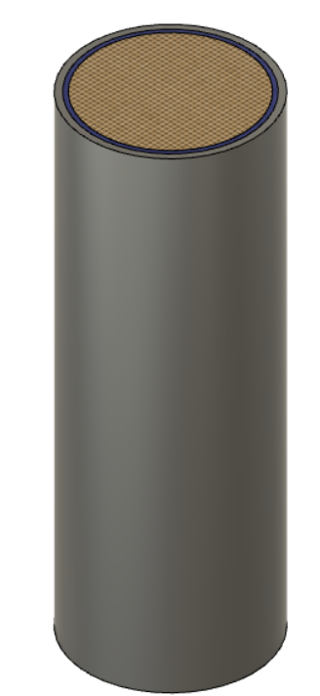

***Figure 8.1.3*** *Different configurations of propellant casting*

Curing time for the KNSU propellant is around 45 minutes to 1 hour beyond which when exposed to outer atmosphere it starts to absorb the moisture content and starts to melt so after the curing time it is advised to store in a proper vacuum sealant. So that it doesn’t get exposed to the outer atmosphere. The pallets seen in the above picture are tested to determine their firing status.

**8.2 PROPELLANT TESTING:**

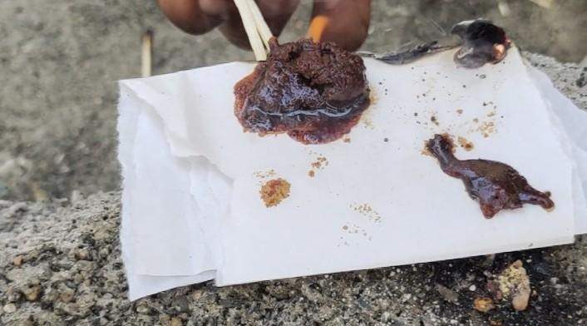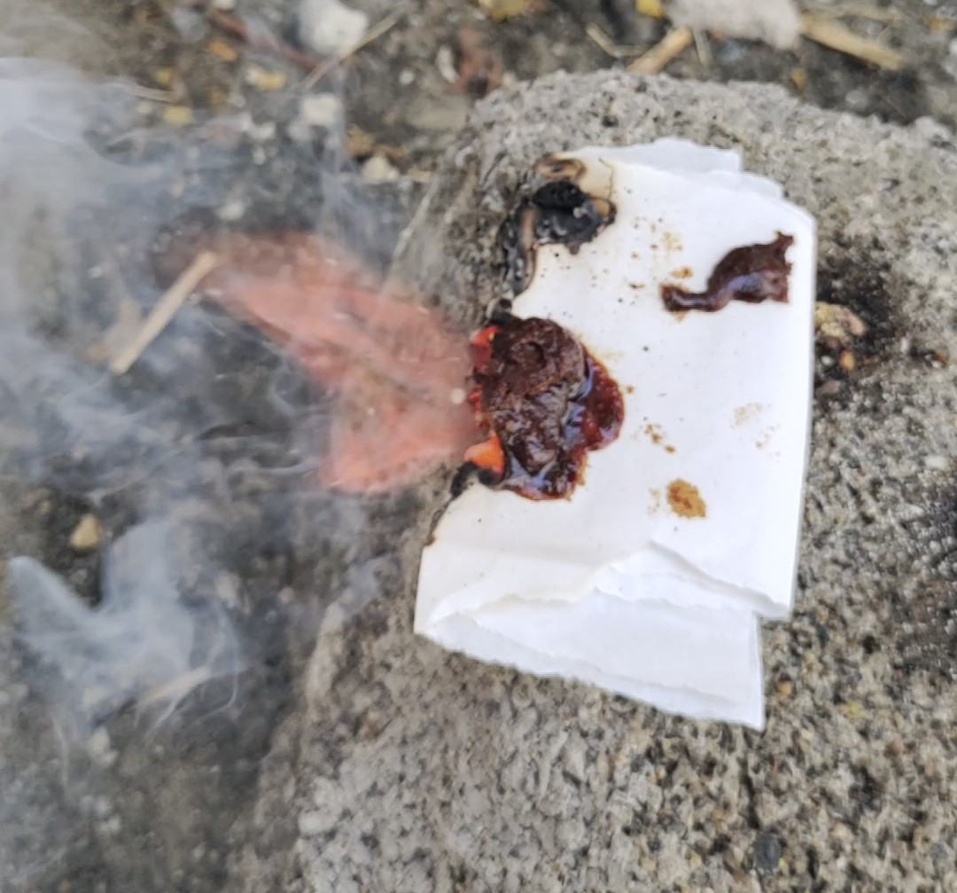

***Figure 8.1.4*** *Pallet at t = 0 secs* ***Figure 8.1.5*** *Pallet at t = 5 secs*

From the above figure, it can be seen that the propellant firing was spontaneous and the only disadvantage is it emits more smoke with small amounts of residue at the end.

**8.3 CONCLUSION:**

Propellant preparation plays a major part in improving the performance of the model and different types of grain configuration leads to different output. The propellant testing helps to make sure that the composition of Potassium Nitrate and sugar is perfect and well suits as a rocket fuel.

**CHAPTER 9**

**STATIC FIRE TESTING**

**9.1 INTRODUCTION**

Static fire testing plays a crucial role in the development and validation of various types of engines and rocket propulsion systems. It is a vital step in the journey of space exploration, ensuring the safety, performance, and reliability of space vehicles. This process involves firing an engine or rocket on the ground, while securely attached to a test stand, to assess its functionality and gather important data before its actual use in flight.

Static fire testing serves several essential purposes. It allows engineers and scientists to evaluate the overall performance of the engine or rocket system under realistic conditions. By simulating the firing sequence and observing the engine's behaviour, they can assess factors such as thrust, pressure, stability, and combustion efficiency. This data helps in refining the design, identifying potential issues, and making necessary adjustments to enhance performance and safety. This static fire for the model is performed to the thrust for different configurations of propellants.

**9.2 INTERNAL BURNING TUBE GRAIN WITH CORE DIAMETER OF 5 MM:**

**Table 9.1** Internal Burning tube grain with core diameter of 5mm

|  |  |
| --- | --- |
| Propellant mass | 170 g |
| Burn time | 120 secs |
| Burn rate | 1.41 $g/s$ |

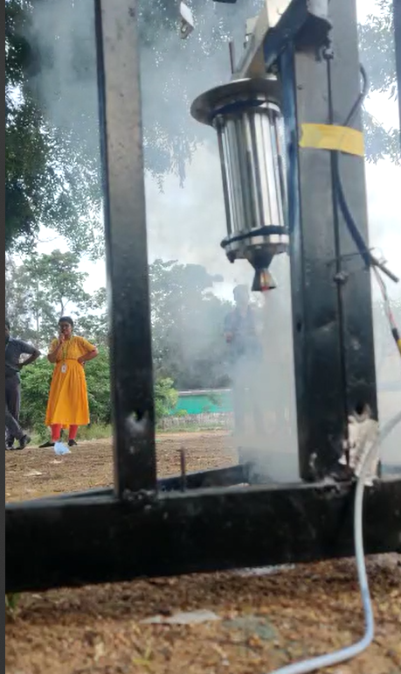

***Figure 9.2.1*** *At T = 0 secs(Internal Burning tube with core of 5mm)*

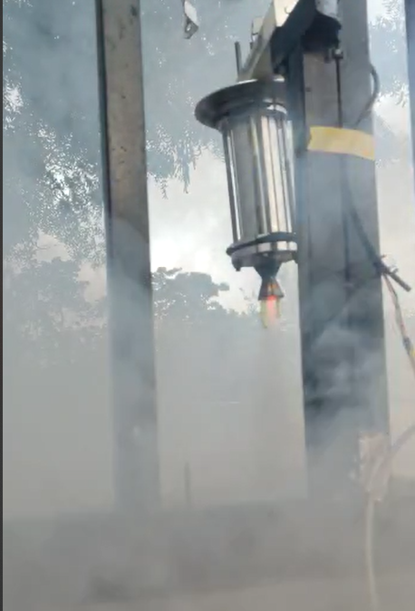

***Figure 9.2.2*** *At T = 30 secs(Internal Burning tube with core of 5mm)*

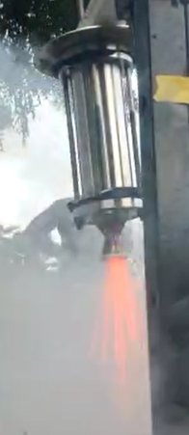

***Figure 9.2.3*** *At T = 70 secs(Internal Burning tube with core of 5mm)*

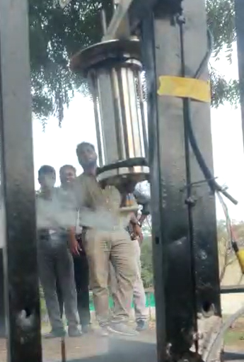

***Figure 9.2.4*** *At T = 120 secs(Internal Burning tube with core of 5mm)*

**9.3 INTERNAL BURNING TUBE GRAIN WITH CORE DIAMETER OF 21 MM:**

**Table 9.2** Internal Burning tube grain with core diameter of 21mm

|  |  |
| --- | --- |
| Propellant mass | 96 g |
| Burn time | 52 secs |
| Burn rate | 1.84 $g/s$ |

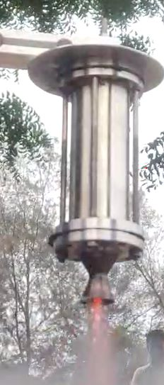

***Figure 9.3.1*** *At T = 10 secs(Internal Burning tube with core of 21 mm)*

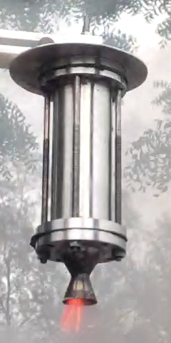

***Figure 9.3.2*** *At T = 25 secs(Internal Burning tube with core of 21 mm)*

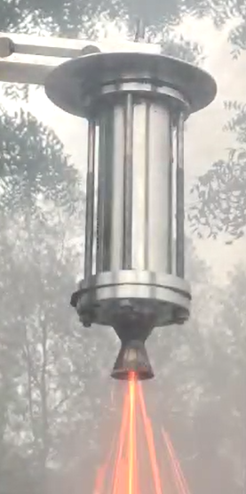

***Figure 9.3.3*** *At T = 45 secs(Internal Burning tube with core of 21 mm)*

**9.4 END BURNING GRAIN CONFIGURATION:**

**Table 9.3** End Burning Grain Configuration

|  |  |
| --- | --- |
| Propellant mass | 210 g |
| Burn time | 135 secs |
| Burn rate | 1.56 $g/s$ |
| Propellant combination  ($KNO_{3}$/Sucrose/Al powder) | 63/32/5 |

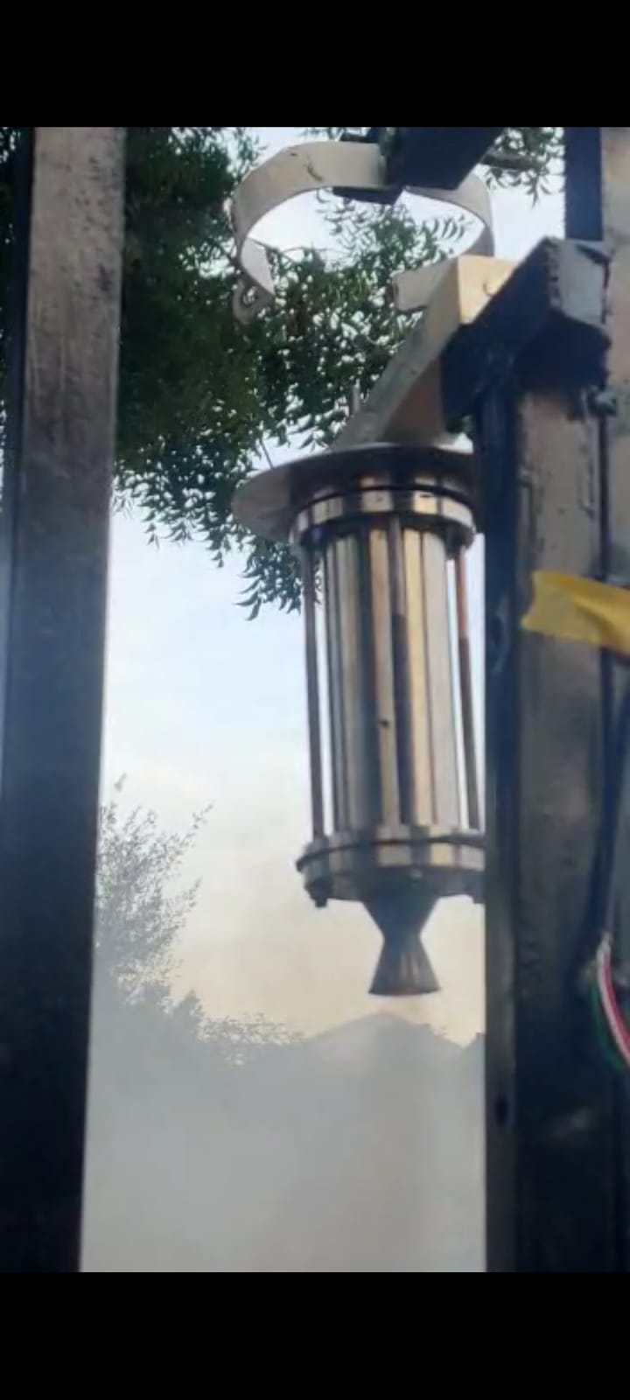

***Figure 9.4.1*** *At T = 0 secs(End Burning Grain Configuration)*

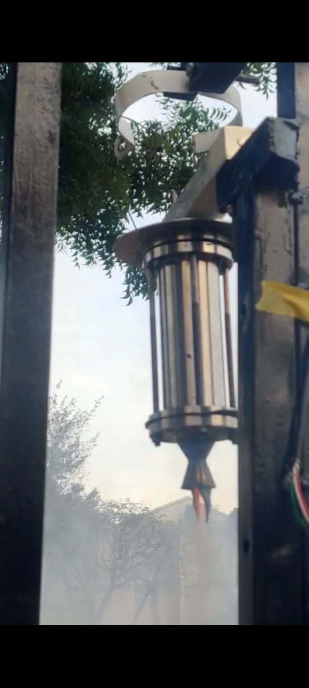

***Figure 9.4.2*** *At T = 40 secs(End Burning Grain Configuration)*

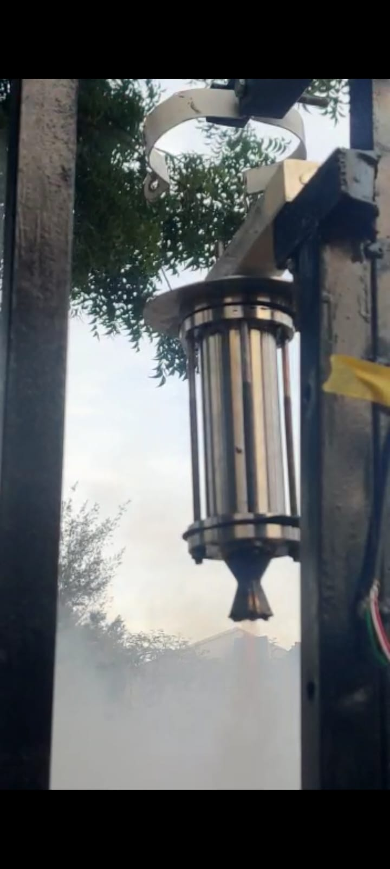

***Figure 9.4.3*** *At T = 90 secs(End Burning Grain Configuration)*

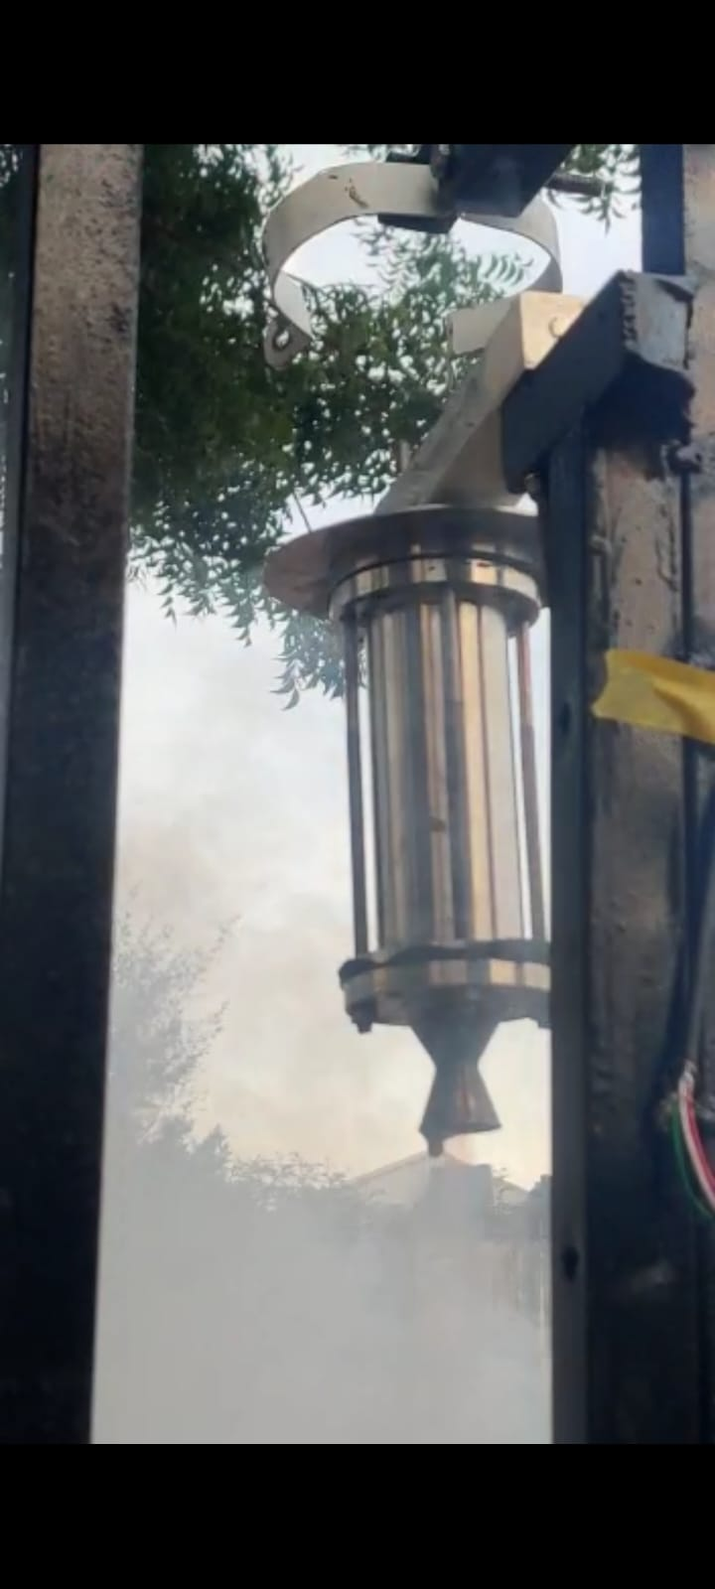

***Figure 9.4.4*** *At T = 130 secs(End Burning Grain Configuration)*

**9.5 AFTER BURN:**

Solid propellants consist of a mixture of oxidizers, fuels, and additives that burn to produce high-pressure gases for thrust or explosive force. Upon combustion, solid propellants undergo chemical reactions that result in the generation of residue or ash. The residue composition varies depending on the specific propellant formulation. Coming to KNSU propellants an additional layer is formed over the Nozzle which in turn reduces the performance of the engine and it also results in the erosion over the combustion chamber which is shown in the below figure.

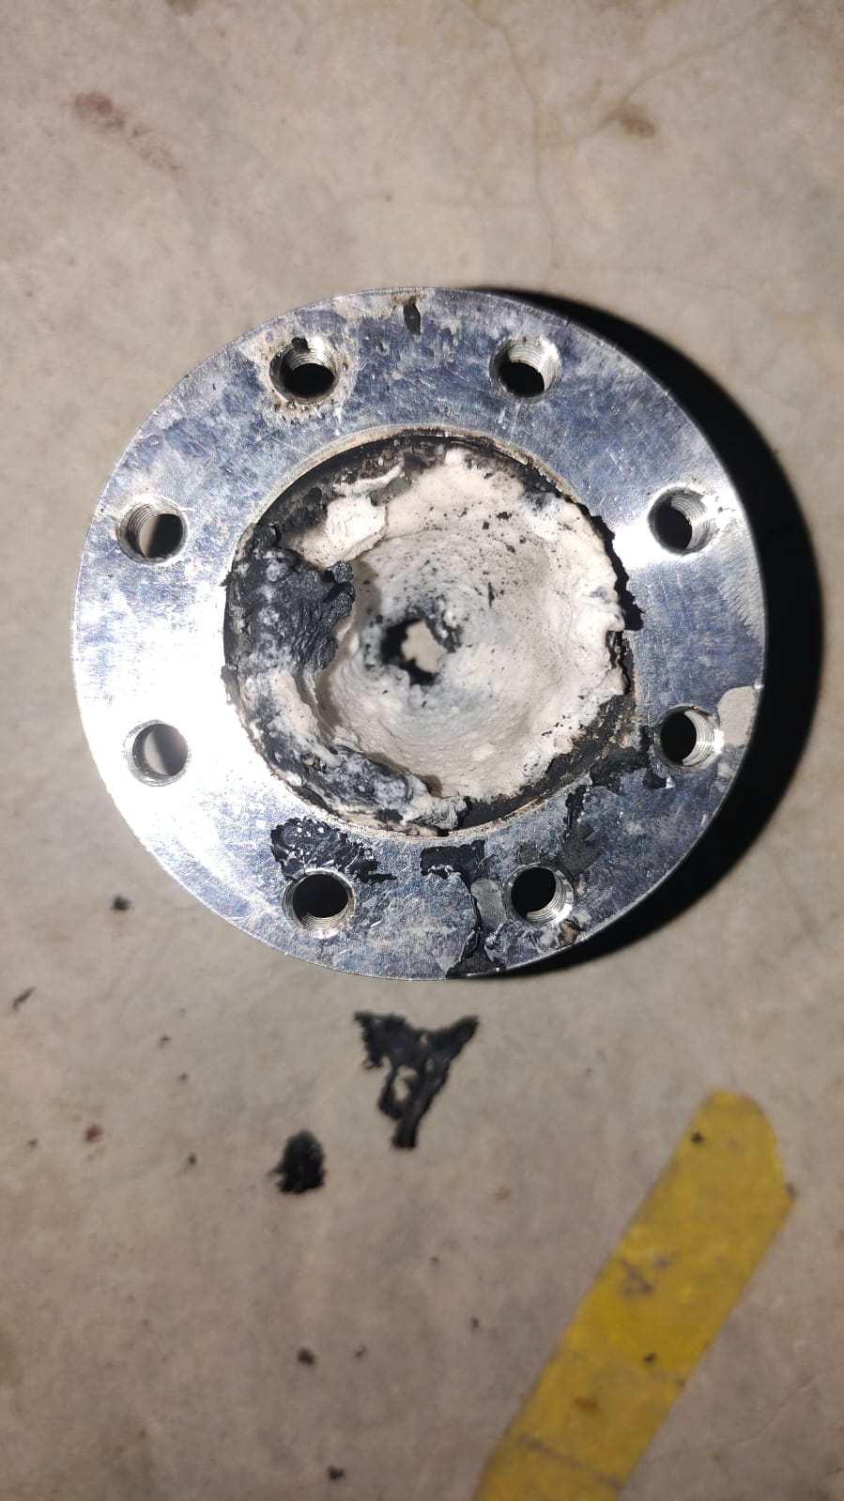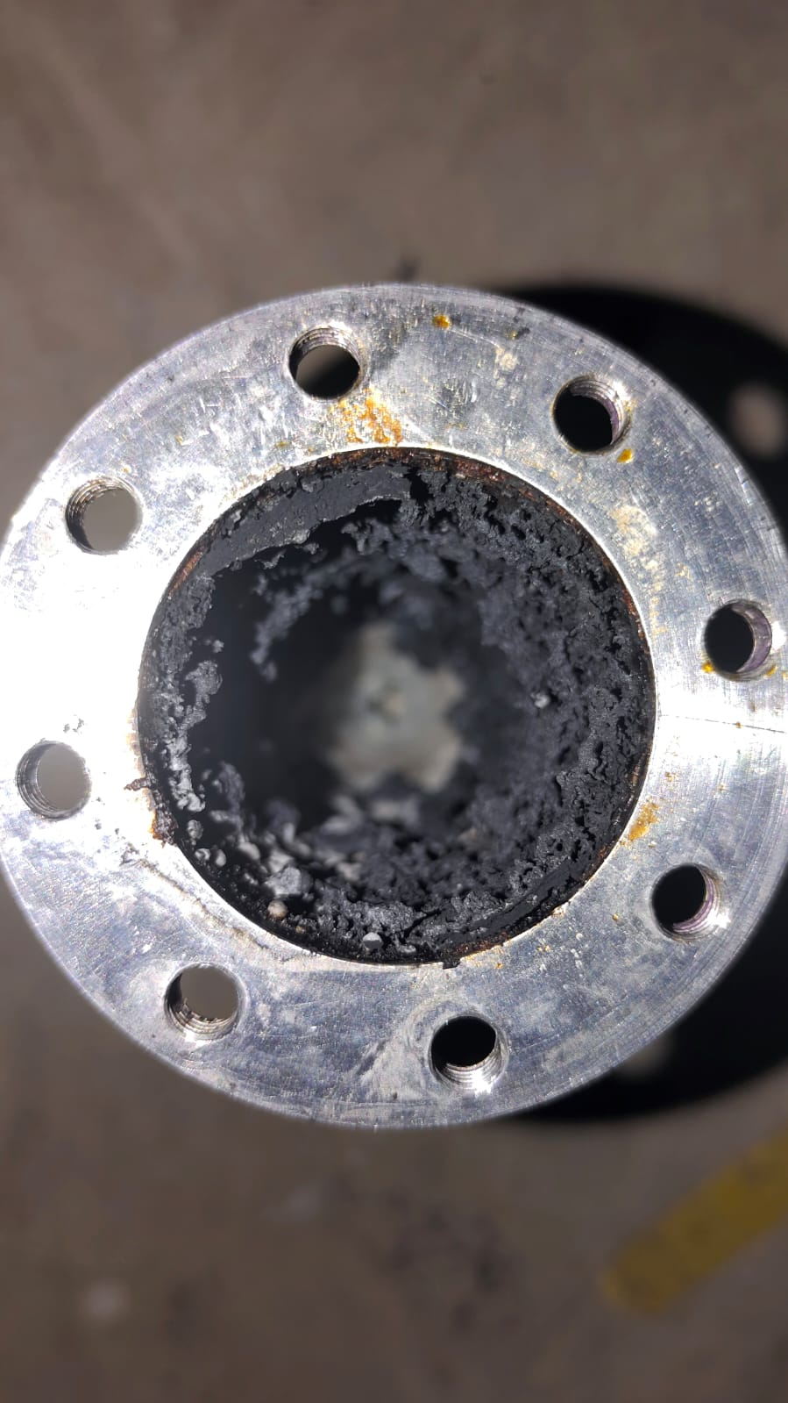

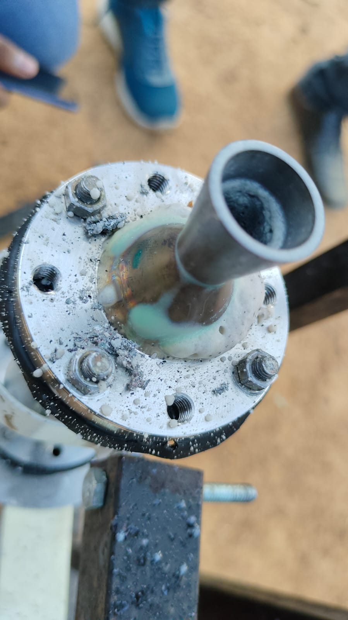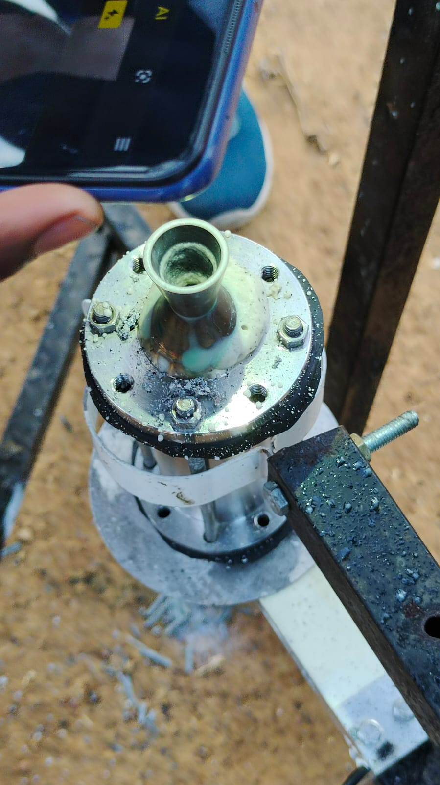

***Figure 9.5.1*** *Residue after the combustion*

**9.6 CONCLUSION**

Among the three static test fires, end burning grain produced more amount of smoke, an erosive layer over the chamber and nozzle, more amounts of residue during burn, the reason behind this is Aluminium powder. Except that remaining

tests are fine and easy to clean as well. The figures before and after burn shows the difference.

**CHAPTER 10**

**RESULTS AND DISCUSSION**

**10.1 INTRODUCTION**

As stated in the previous chapter, for the static test firing, the load cell as thrust measurement device which helps in giving the weight of the model as output at various time steps is used to plot the graphs of thrust vs time for various grain configurations and helps to compare experimentally.

**10.2 INTERNAL BURNING TUBE GRAIN WITH CORE DIAMETER OF 5 MM:**

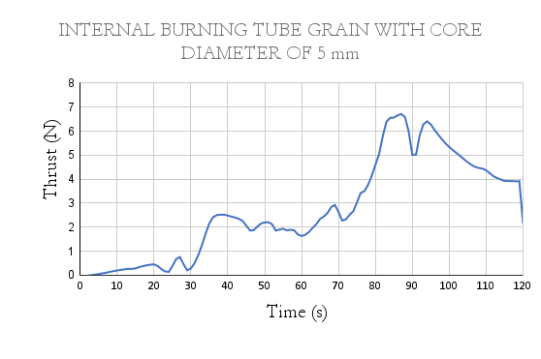

***Figure 10.2.1*** *Thrust vs Time(Internal Burning tube of core 5mm)*

**Table 10.1** Results for Internal burning tube of core 5mm

|  |  |
| --- | --- |
| Peak Thrust | 6.71 N |
| Average Thrust | 2.73 N |
| Total Impulse | 327.6 Ns |

**10.3 INTERNAL BURNING TUBE GRAIN WITH CORE DIAMETER OF 21 MM:**

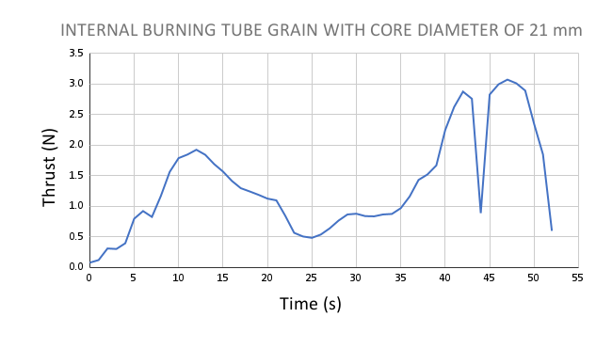

***Figure 10.3.1*** *Thrust vs Time(Internal Burning tube of core 21mm)*

**Table 10.2** Results for Internal burning tube of core 21mm

|  |  |
| --- | --- |
| Peak Thrust | 3.2 N |
| Average Thrust | 1.35 N |
| Total Impulse | 70.2 Ns |

**10.4 END BURNING GRAIN CONFIGURATION:**

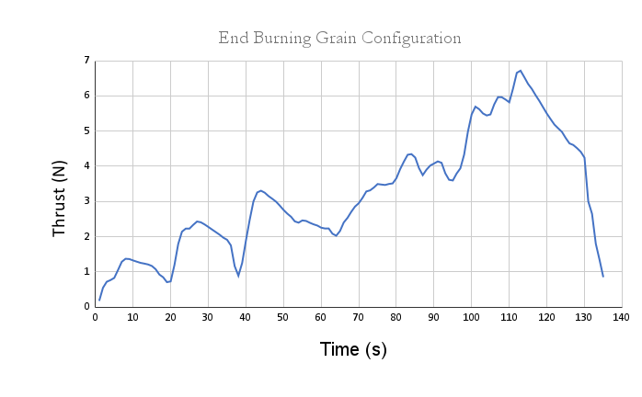

***Figure 10.4.1*** *Thrust vs Time(End Burning Grain)*

**Table 10.3** Results for End Burning Grain

|  |  |
| --- | --- |
| Peak Thrust | 6.71 N |
| Average Thrust | 3.18 N |
| Total Impulse | 429.3 Ns |

By comparing all the three results it is evident that the average thrust is maximum with the end burning propellant grain when compared to the remaining propellant configurations.

**10.5 VALIDATION:**

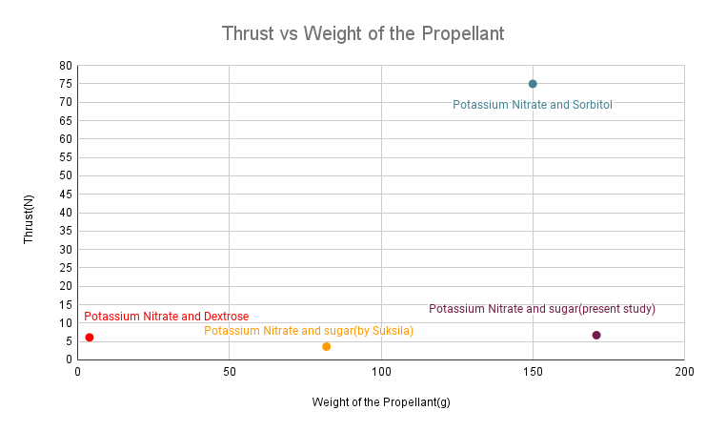

***Figure 10.5.1*** *Comparison of Thrust vs weight with different studies*

The experimentation conducted by various studies with various compositions of propellants are compared with the present study and a graph has been plotted which shows better results when compared to the previous experimentation by Suksila[5] who worked mainly on KNSU propellants.

**10.6 SUMMARY**

All the results from the static tests have been plotted and many experimental results are validated with the present study. When compared with the theoretical expectation of 10 N Thrust, got around 6.71 N as peak thrust. The difference in the thrust values is due to less chamber pressure which is well seen in reduction of mass flow rate.

**CHAPTER 11**

**CONCLUSION AND FUTURE ENHANCEMENTS**

**11.1 INTRODUCTION**

The results are obtained for the small scaled rocket and with the usage of KNSU propellant, to further launch the small satellites to outer space, the rocket size and the propellant need to be upgraded.

**11.2 LIMITATIONS OF THE PRESENT STUDY**

The following are the limitations observed in the present study:

* Low specific impulse compared to the composite propellants like HTPB, APCP..
* Stainless steel doesn't resist higher temperatures for a longer burn duration.
* The nozzle is a combination of conical and Bell nozzle so there exists some minor losses.

**11.3 FUTURE ENHANCEMENTS**

* Nozzle design can be modified to a double bell shape to minimise the losses.
* Rocket can be scaled to a larger size with higher specific impulse propellants.
* Scaled rockets can be used for launching Femto satellites upto 200 kms as shown in the figure below.

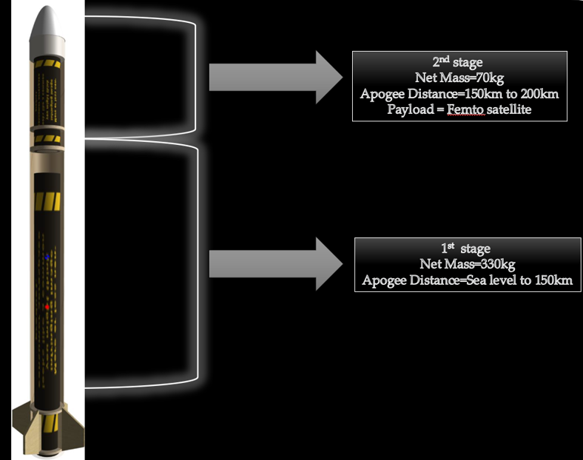

***Figure 11.3.1*** *Scaled Rocket Model(Future Enhancement)*

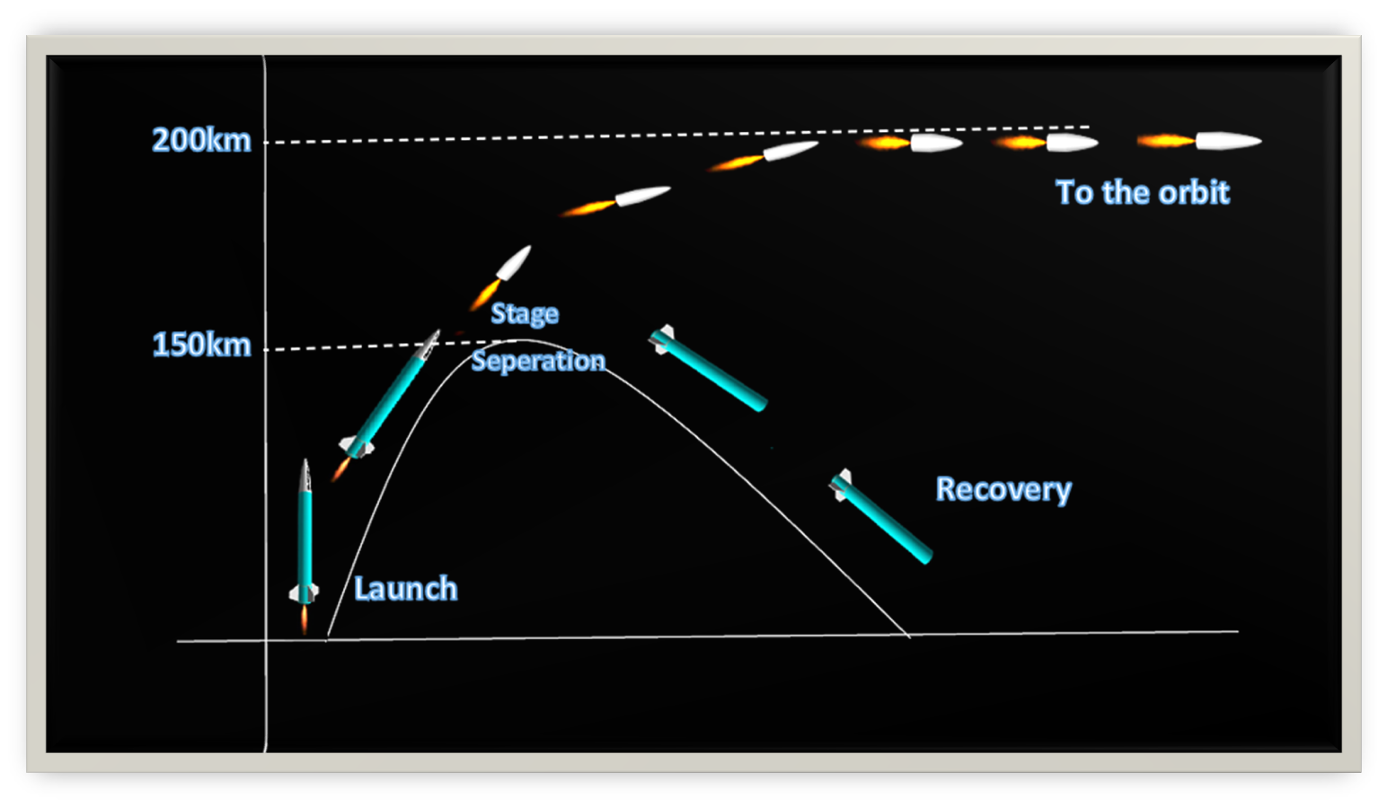

***Figure 11.3.2*** *Flight plan for scaled rocket model(Future Enhancement)*

**11.4 CONCLUSION**

Finally the static test of KNSU propellant paves way for making larger rockets with better efficient problems

**REFERENCES**

1. Michal Malek, Design and characterization of small solid-propellant rocket engine, Czech Technical University in Prague, Bachelor Thesis, 2019.
2. B. Dequick, M. Lefebvre, P. Hendrick, CFD Simulation of a 1kN Paraffin-Fueled Hybrid Rocket Engine, American Institute of Aeronautics and Astronautics(AIAA), 2020.
3. Rasheed O. Durojaye, Olusegun A. Adefuye , Nurudeen A. Raji, Elkanah O. Ouetunji, Design Analysis of Mild Steel Combustion Chamber for a Sugar Base Propellant of a Solid Rocket Motor, World Journal of Innovative Research (WJIR), 2018.
4. Nevin Nelson, A. Yezhil Arasu, B. Kiran Kumar, Thomas Kurian, Stress Analysis of Solid Rocket Motor Case, International Research Journal of Engineering and Technology (IRJET), 2020.
5. Thada Suksila, Experimental investigation of solid rocket motors for small sounding rockets, IOP Conf. Series: Materials Science and Engineering 297(2018).
6. Richard A Nakka, Richard Nakka's Experimental Rocketry Website, 2007.
7. Sidhant Singh, Solid Rocket Motor for Experimental Sounding Rockets, Advances in Aerospace Science and Applications,ISSN 2277-3223 Volume 3, Number 3 (2013)
8. George P. Sutton, Oscar Biblarz, Rocket Propulsion Elements, A Wiley-Interscience publication, 7th Edition, 2001.
9. Richard A Nakka, SRM 2014.xls, Revised: 1 May 2020.